Nanowood / Hardened Wood Worksheet

November 1, 2021

[On-Demand Class]

1. List five examples of wood or wood products in your daily life:
2. [例] my bookcase
3. ______________________________
4. ______________________________
5. ______________________________
6. ______________________________
7. ______________________________
8. Look up and write definitions for the following vocabulary words:
9. sustainable __________________________________________________________________
10. material ____________________________________________________________________
11. alternative __________________________________________________________________
12. optimistic ___________________________________________________________________
13. potential ____________________________________________________________________
14. rigid ________________________________________________________________________
15. polymer _____________________________________________________________________
16. On the Internet, check the **United Nations Sustainable Development Goals** [SDGs].
17. How many SDGs are there?
18. What is the purpose of these SDGs?
19. If you could do a volunteer activity to help achieve one of the goals, which goal would you choose? Why?
20. Watch video (2) “nanowood video” on our class webpage.
21. Read the nanowood article, either on (3) its webpage or using the (4) nanowood script.

Continue to page 2 😊

1. 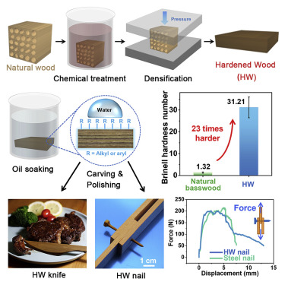Look carefully at the picture 🡺   
   of the process of making ‘hardened wood’. In your own words, describe the process and the results. (100-150 words)
2. Watch the three ‘wood densification” videos on our class webpage, (5)-(7).
3. Answer the following question in 100-150 words.

*“How do you think nanowood and hardened wood can benefit future generations?”*