Good morning, everyone. In today’s classes we’ll be talking about the life of you good people—in other words, we’ll be talking about student life. To help you out, here are some questions for your consideration.

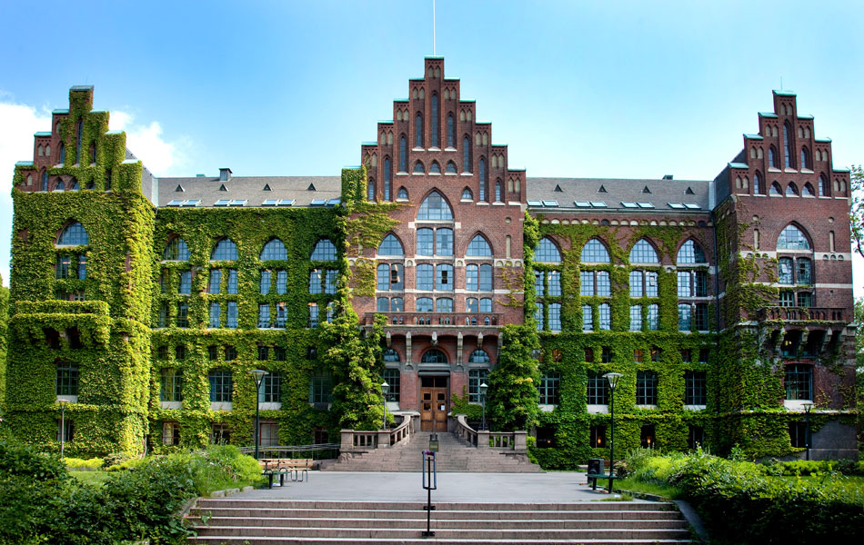

1. How long have you been a student? (Think carefully!)

2. What is your major and why did you choose it?

3. What type of housing do you have? Why that particular type?

4. Do you live alone? Why or why not?

5. Describe your typical day of food.

6. Do you have a part-time job? Why or why not?

7. Do you plan on pursuing a graduate degree? If so, what kind?

8. Did your parents attend university? How about your grandparents?

9. Universities should graduate in four years—agree or disagree? Why?

10. The university exam system is ______________. (Please explain your answer.)

11. My favorite teacher was/is ____________________. (Please explain your answer.)