**Comprehension Questions**

1. What were the findings of most early studies on paper versus screen reading?

A. Most early studies found that screen reading was more effective than paper reading.

B. Most early studies found there were no major differences between screen reading and paper reading.

C. Most early studies found that paper reading was more effective than screen reading.

D. Most early studies found that people were showing a preference for screen reading over paper reading.

2. Why does Virginia Clinton say “reader preference” is a key thing to consider when looking at her findings?

A. Because a person will pay more attention and be more involved when reading in the way they most prefer.

B. Because most people prefer screen reading to paper reading.

C. Because paper reading is preferred only by older people, so the results of similar studies in the future might be different.

D. Because people generally enjoy screen and paper reading equally.

3. What is a reason Clinton gives for why screen readers have an inflated sense of their understanding of a text?

A. They may be more tired from looking at a screen.

B. They may lose their place in the text more easily.

C. They may think what they are reading is too easy for them.

D. They may be more distracted.

4. What have several studies shown about people's attitudes toward paper reading materials?

1. People often consider paper to be unimportant.

2. People often view paper materials as important.

3. People often view paper materials as outdated and boring.

4. People often consider paper materials to be hard to find.

**Vocabulary.**

Mark the context of the words in the story. Next, write the part of speech (e.g., adj.) and a definition in English.

(例) significant – (adj.) large enough to be noticed or have an effect

text –

efficient –

distracted –

focused –

appropriate –

response –

_________ –

_________ –

_________ –

**Paragraph Purpose**

Using the list on p. 17 of our food reading from last week (below), choose the purpose of each paragraph in this story.

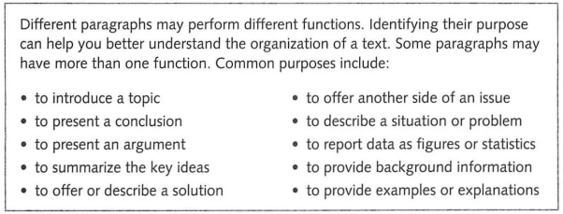

Paragraph 1 (If you want to make sure…) ________________________________

¶2 (Researchers …) _____________________________________

¶3 (Clinton’s aim …)_____________________________________

¶4 (Clinton’s examination …)_____________________________________

¶5 (Clinton also …) _____________________________________

¶6 (Clinton and … )_____________________________________

¶7 (However, …) _____________________________________

¶8 (On the other hand, …)_____________________________________

¶9 (Several studies …)_____________________________________

¶10 (Although her findings …) _____________________________________

¶11 (Other tools …) _____________________________________

**Expansion**

Consider and answer the following questions.

1. Of the reading that you do, how much is on a screen and how much is on paper?
2. For you, is there a difference between reading on a screen and reading on paper? If so, describe the difference(s) you feel.
3. Do you think students learn better from reading on a screen or on paper? Why?
4. “Elementary school students should only read on paper.” Do you agree or disagree with this? For what reasons?

**Finally, one more reading …**

There are many components, factors and conditions that can come into play here, such as the reader, the material, the purpose and the technology. Not only the reader’s proficiency, background and expectations must be kept in mind, but also the type of material that is being referred to and the kind of screen that is being used. It is not a case of “one size fits all,” but patterns are beginning to emerge from empirical research into the subject. The length of the text seems to be the most critical factor. If the text is long, needs to be read carefully and perhaps involves making notes, then studies show that many people, including young people such as students, still often prefer a printed book, even if it is available as both an e-book and in electronic formats with options for making notes, enabling the user to search for and highlight the text digitally. This is not the case when it comes to shorter texts.

*https://learningenglish.voanews.com/a/study-paper-reading-more-effective-than-screen-reading/4876473.html*

*https://phys.org/news/2017-09-differently-paper-screen.html*