In this handout we will be meeting our friend, Google Drive. This is an easily-used method of storing, sharing, and otherwise utilizing materials, and it is our method for doing so in this class. Thus, welcome to Google Drive.

The first step in this process is for us to invite you to share (“collaborate”) a Google Sheets document (which is basically an Excel document) called English Core II-A Word Bank – Spring 2017. This is located in Google Drive. To access this folder you’ll need a Google account, which many of you probably already have.



You first need to send me a polite e-mail asking me to invite you to collaborate, and when I then invite you do so, you will receive the following message.

You need to open the email, whereupon you’ll see the following message …

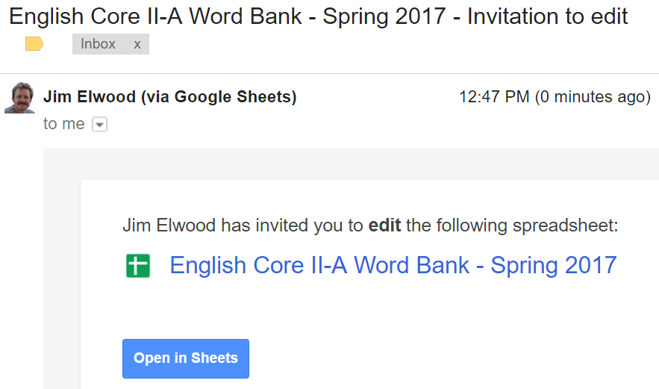

When you cleverly click the “Open in Sheets” button, the file should open for you.

Along the bottom of this page you’ll see a row of tabs for different worksheets; one tab will have your name on it.

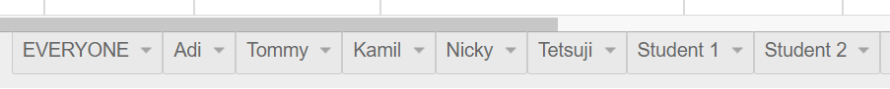

The leftmost tab, EVERYONE, is where I’ll compile the entire word bank for our class. You’ll also see five tabs titled Adi, Tommy, Kamil, Nicky, and Tetsuji; those are former students who did very nice work on their respective pages. Take a look at these five examples.

Your job, of course, is to add words to your page (“worksheet”) at a rate of five per week (or more).

If you think about this, we will eventually have some 35 students doing 5 words per week over 15 weeks, so our class total will be about …

35 x 5 x 15 = 2625 words ☺

In the upper, righthand corner of this page you’ll see a blue link that will allow you to “Open in Drive”, which will add this folder to your own, personal Google Drive.

I will explain the various columns during class.

Note that you can access Google Drive from your Gmail page. You’ll need to click the dots icon, which will then show the following:

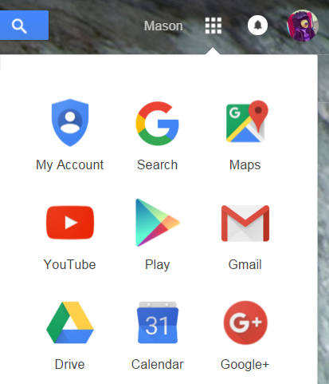

Allow me to finish with two things of note:

1. You can download Google Drive onto your computer, but it is NOT necessary to do so.

**2. Do not delete our Word Bank file, please!**