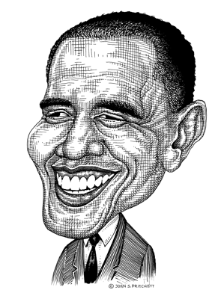
1. Is life a bowl of cherries or a journey? Why or why not?
2. Other examples of metaphors…
3. Stereotype—first, what exactly is a stereotype?
4. Please write 2-3 examples and be prepared to explain them.
5. Can you think of any valid stereotypes?
6. What is one example of an erroneous stereotype?

Your homework: visit this website and find examples of stereotypes.
http://cartoonbox.slate.com/index/

