Complex Machine Report:   
Smartphone

Tomoko Aoyama

English Core II-C

Dr. Elwood

January 25, 2019

I will lock at the structure of the smartphone from now. The first one is a liquid crystal panel. This is on the screen we touch. But why can you operate it by touching the screen directly? Currently the most widely adopted detection method in the touch panel market is that “resistive film method”. It is often called “pressure sensitive type” or “analog resistance film type”.

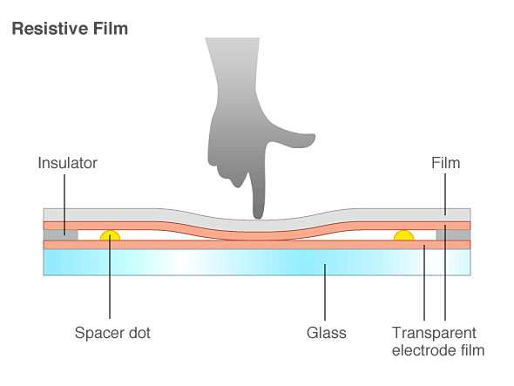

*Figure 1. Resistive Film*

The second one is the electronic circuit. An electronic circuit is a circuit including active elements such as diodes and transistors as components. Electronic circuits include analog electronic circuits and digital electronic circuits. They can amplify, calculate, and transfer date. 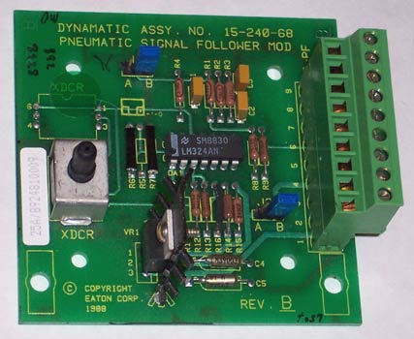

*Figure 2.* Electronic circuit

The third and fourth are cameras and speakers. Thanks to the camera, we can tame pictures and movies with smartphone. Also thanks to the presence of speakers, you can make phone calls and watch videos with sound.

Next, I will examine the function of the smartphone. The first one is the GPS function. GPS will determine your current location, and will tell you the destination a nd direction etc using the map application. Secondly, you can send mail. With this, it because easy to contact with friends. Third, we can see the Internet. Until the smartphone appeared, it because very convenient because it could only be seen on a personal computer. Fourth, we can enjoy the games. There are a lot of games that can be downloaded for free now and it will also be a time killer. Fifth, we can shop with a smartphone. In convenience stores and restaurants, we can use smartphones instead of wallets. Even without an IC card, it touches the smartphone and it plays the role of an IC card now.

In this way, with various functions of the smartphone we are easier to live. Let’s live with gratitude for the development of technology.

**References**

**https://tech.nikkeibp.co.jp/it/article/COLUMN/20120822/417461/**

**https://www.researchgate.net/figure/Resistive-Film_fig1_281715755**