English Core Ⅱ-C

Toshiya Fujita

January 19, 2019

An ordinary car is a ride that generally runs on the road with 1~8people. The body with more than 1ton is made of metal and the size and the color are various. The car is not only engines, a body that supports the car itself, an engine that creates power, a transmission that transmits power. It is a comprehensive existence of industrial technology such as drive train to convey it, brake to stop, steering to bend.

[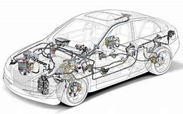](https://www.bing.com/images/search?view=detailV2&ccid=zitxZ6N3&id=48B7D938D6FBB29E688476084BAF462491934631&thid=OIP.zitxZ6N3-iJ2dXUoBt8KwAHaEK&mediaurl=http://blog.autointhebox.com/wp-content/uploads/2015/04/Getting-deeper-into-car-electrical-system-874x492.jpg&exph=492&expw=874&q=car+system&simid=608003153880416749&selectedIndex=17&cbir=sbi)*Figure1:*　Car structure

Generally, the size of the engine is about 70 liters and is made of cast iron. In an engine, fuel is burned and chemical energy is converted into kinetic energy. This creates the power of the car.

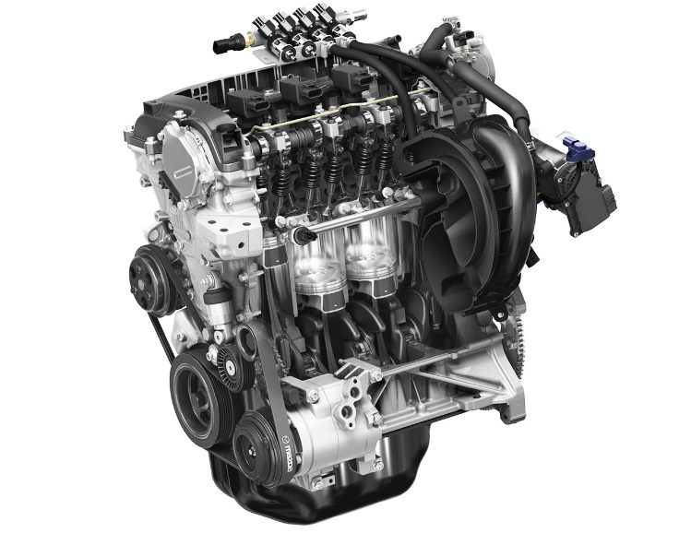

*Figure2:*  The engine

A transmission is a device that takes out driving force made of an engine and transmits power. There are two kinds of cars, automatic and manual, made of combinations of large and small gears. Shift according to the situation such as when necessary, efficiently transmit power.

[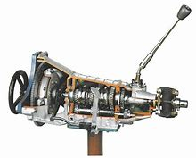](https://www.bing.com/images/search?view=detailV2&ccid=oLCza4op&id=95BDD7A120AB236217068C6B109C0E4639E58737&thid=OIP.oLCza4opeXTATXiYNlrtdQHaF7&mediaurl=https://www.hokkaido.seikyou.ne.jp/hokkai/wp-content/uploads/sites/2/2016/09/f6e6fe21107a4f71c5518d2c58b6ca43.jpg&exph=768&expw=959&q=%e8%bb%8a+%e3%83%88%e3%83%a9%e3%83%b3%e3%82%b9%e3%83%9f%e3%83%83%e3%82%b7%e3%83%a7%e3%83%b3&simid=608042925290883802&selectedIndex=3&cbir=sbi)

*Figure3:* The transmission

Next, it is a tire. (*Figure4*) It is covered with black rubber in a circular metal. Air is contained between metal and rubber, making it a system capable of withstanding loads, shocks, pneumatic pressure and the like. The car body advances smoothly by turning the road so that its rubber follows. Driving power is necessary for a car to run. Gain driving power and advance the car forward by friction between the tire and the road surface.

[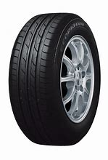](https://www.bing.com/images/search?view=detailV2&ccid=hGf0zLqm&id=E550C3E91816DBC2F3475FEFA64F754197677CC1&thid=OIP.hGf0zLqmL0hgXUV997hy6AHaK-&mediaurl=http://yoshida-taiya.co.jp/ex10.gif&exph=1579&expw=1065&q=%e3%82%bf%e3%82%a4%e3%83%a4&simid=608035082676079532&selectedIndex=0)

*Figure4:* The tire

The brake device is behind the tire and has a function to stop the car body. The brake transmits brake pedal depression force to brake by “brake fluid” to make it braking force. Physically, brakes are devices that convert kinetic energy into thermal energy. Most of the current cars have a brake booster, and the car stops lightly when you step on the brake pedal lightly.

[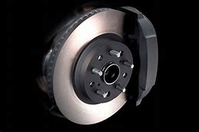](https://www.bing.com/images/search?view=detailV2&ccid=4CdQfKAR&id=FF75D9570BF72206C5E7D10A7BDF4D8E56C57A6D&thid=OIP.4CdQfKARf7PTKfsqmEHBzQHaE8&mediaurl=http://bbs44.meiwasuisan.com/car/img/13864022550001.jpg&exph=427&expw=640&q=%e3%83%96%e3%83%ac%e3%83%bc%e3%82%ad%e8%a3%85%e7%bd%ae%e3%80%80%e8%bb%8a&simid=608009802528065570&selectedIndex=21&cbir=sbi)

*Figure5:*  The brake device

The steering wheel is a tool for steering the driving in the driver's seat, mainly used when turning. Steering is a device that changes the direction of a tire by changing the rotational motion to a linear motion using the force transmitted from the steering wheel. When the car turns, it rolls around the roll center and turns. In addition, the roll center is different on the front and the rear, and the axis connecting the roll center is called rolling axis.

[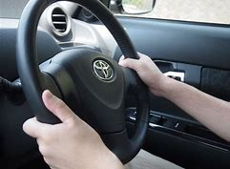](https://www.bing.com/images/search?view=detailV2&ccid=4xkSsnZ8&id=A92D934973637C55FD44C7AFCD8184DCA136EF03&thid=OIP.4xkSsnZ8bqupGjSfug86RgHaFj&mediaurl=http://tease-taisaku.com/wp-content/uploads/2016/02/a5a462235626f7577b03d3d5652febd5_s.jpg&exph=480&expw=640&q=%e3%83%8f%e3%83%b3%e3%83%89%e3%83%ab%e3%80%80%e8%bb%8a&simid=608010554138560431&selectedIndex=3&cbir=sbi)

*Figure6:* The steering wheel

Mirror window, see, because the car is sitting and driving, there is a blind spot. Windows and mirrors are tools to minimize their blind spots. The window uses 4 large glasses from the chest to the top of the head so that the surroundings can be seen widely from the driver’s seat. The mirror is attached to each side of the car body so that the rear part of the car body can be seen.

[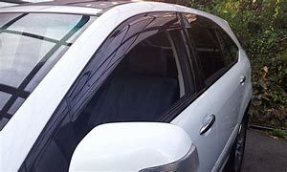](https://www.bing.com/images/search?view=detailV2&ccid=L4xvNbB3&id=D777C505569DACF6E1A47EE3345F667E65E2BB25&thid=OIP.L4xvNbB36AKPYmR8phKYmgHaEd&mediaurl=http://blog-imgs-48.fc2.com/l/a/i/lair0102/2013-10-2.jpg&exph=1232&expw=2048&q=%e7%aa%93%e3%80%80%e8%bb%8a&simid=608027063941529969&selectedIndex=259&cbir=sbi)[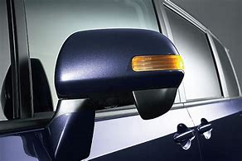](https://www.bing.com/images/search?view=detailV2&ccid=9uUNwFQo&id=F7127CC93E65D9746FA3C7F512E8470122697E1D&thid=OIP.9uUNwFQox77okpfEnhUXzgHaE8&mediaurl=http://www.carsensor.net/contents/article_images/_6588/Yougo_Winker.jpg&exph=427&expw=640&q=%e3%81%bf%e3%82%89%e3%83%bc%e3%80%80%e8%bb%8a&simid=608034605941918839&selectedIndex=1&cbir=sbi)

*Figure7:* The window and the (side) mirror

The light is installed in front of and behind the car body, and it shows where the car goes. I light the traveling direction with the light. Therefore, it is possible to drive safer. The light is installed in front of and behind the car body, and it shows where the car goes. I light the traveling direction with the light. Therefore, safer driving is possible.

[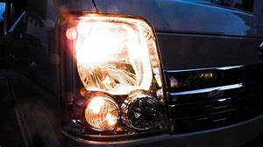](https://www.bing.com/images/search?view=detailV2&ccid=kNCjM8mL&id=771645FB6097F62C595A4268C886A8A45611906F&thid=OIP.kNCjM8mLRUAyYOLNHSKD3AHaEK&mediaurl=https://carlike.jp/wp-content/uploads/2017/01/car-right.jpg&exph=675&expw=1200&q=%e8%bb%8a%e3%80%80%e3%83%a9%e3%82%a4%e3%83%88&simid=608055453663103014&selectedIndex=28) [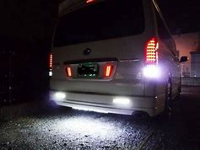](https://www.bing.com/images/search?view=detailV2&ccid=T444PR7g&id=9A33CB385924009C597CAF990DA3EBCDF4B3D31D&thid=OIP.T444PR7gT0rhhF2-KwqT-QHaFj&mediaurl=http%3a%2f%2fcdn.mkimg.carview.co.jp%2fminkara%2fparts%2f000%2f004%2f057%2f840%2f4057840%2fp1.jpg%3fct%3d9b67d12f92fe&exph=480&expw=640&q=%e8%bb%8a%e3%80%80%e3%83%90%e3%83%83%e3%82%af%e3%83%a9%e3%82%a4%e3%83%88&simid=608047941837522564&selectedIndex=43)

*Figure8:* The light

An airbag is a device to protect a person riding when an accident occurs. When an accident happens, the car body receives a great impact. Simultaneously with the impact, the air bag has the effect of taking out the cushion and softening its impact.

[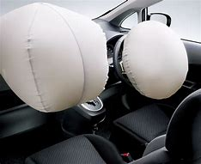](https://www.bing.com/images/search?view=detailV2&ccid=sb9Ybdlp&id=3ABFE9B273CB3FEF4CCE60F987DEFE65BB25759C&thid=OIP.sb9YbdlpUVQInNmYDCkQUQHaGD&mediaurl=http://clicccar.com/wp-content/uploads/2013/04/0131.jpg&exph=523&expw=640&q=%e8%bb%8a+%e3%82%a8%e3%82%a2%e3%83%90%e3%83%83%e3%82%af&simid=608008698717078434&selectedIndex=0&cbir=sbi)

*Figure9:* The airbag

A seat belt is safety device. The seat belt is made by knitting polyester and it is very firm. When sudden braking is done, the occupant jumps forward due to the inertial force. However, by restraining the occupant's body to the seat, it can be prevented from being thrown out of the seat and injured.

[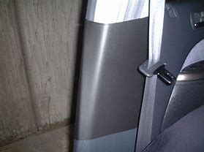](https://www.bing.com/images/search?view=detailV2&ccid=WdeZgULc&id=EB2E602B78DBD925CB844304CAB5316B36D73863&thid=OIP.WdeZgULc0hvIdST_tA7zBQHaFj&mediaurl=http://cdn.snsimg.carview.co.jp/carlife/images/UserCarNote/1431/p1.jpg?ct%3d592bf8fa12b4&exph=480&expw=640&q=%e8%bb%8a+%e3%82%b7%e3%83%bc%e3%83%88%e3%83%99%e3%83%ab%e3%83%88%e3%80%80&simid=607993932601231465&selectedIndex=42&cbir=sbi)

*Figure10:* The seat belt

Reference

* <http://www.tcmit.org/exhibition/car/car02.html>
* <http://www2.nissan.co.jp/?sclisid=LS_TIJ_99_YJ_YLIS_00285482>
* <https://www.bing.com/images/search?view=detailV2&id=CF57752FAC0DD3F0ACF5D75C35D52558B2EC652A&thid=OIP._CuBTR225tXq3D1bx7MU-QHaEY&mediaurl=http%3A%2F%2Fmotorfan-i.com%2Fimg%2FjyufukuMV.png&exph=278&expw=470&q=%e8%87%aa%e5%8b%95%e8%bb%8a+%e4%bb%95%e7%b5%84%e3%81%bf&selectedindex=1&ajaxhist=0&vt=0&eim=1,6>
* <https://car-moby.jp/8166>