Complex Machine Report:   
The International Space Station

Hanako Aoyama

English Core II-C

Dr. Elwood

January 21, 2019

Space exploration has long fascinated humans, and over the last 75 years we have ventured into space. From the Moon landings to the many probes that have traveled through our solar system and beyond, space exploration has progressed rapidly. One ongoing project is the International Space Station (ISS), which is a collaborative effort among the space agencies of four countries (the United States, Japan, Russia, and Canada) and the European Union (Space Station, 1999). In this essay I will describe some of the ISS parts and their functions.

The ISS was launched in 1990 and now is a fully functioning facility that can host up to seven astronauts. As shown in Figure 1, it consists of viverra imperdiet enim. Fusce est. Vivamus a tellus. Pellentesque habitant morbi tristique senectus et netus et malesuada fames ac turpis egestas. Proin pharetra nonummy pede. Mauris et orci. Aenean nec lorem.

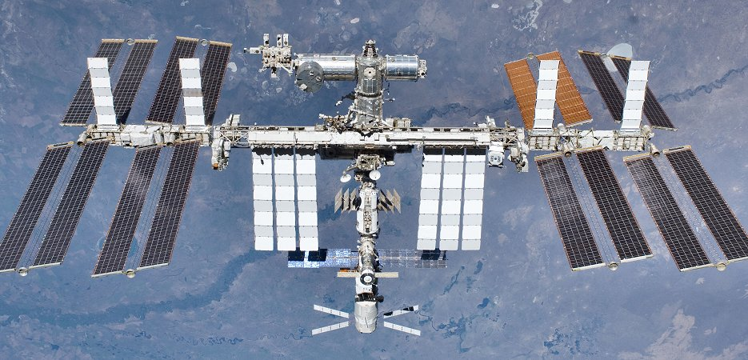

*Figure 1.* The International Space Station

The first part I would like to explain is the solar panels, which are the dark rectangular pieces that look like wings. Each of the four arrays is actually 34.1 x 11.9 meters, and together they produce about 100 kW of electricity, which is enough to power 40 homes on Earth (Garcia, 2017). Fusce posuere, magna sed pulvinar ultricies, purus lectus malesuada libero, sit amet commodo magna eros quis urna. Nunc viverra imperdiet enim. Fusce est. Vivamus a tellus. Pellentesque habitant morbi tristique senectus et netus et malesuada fames ac turpis egestas. Proin pharetra nonummy pede. Mauris et orci. Aenean nec lorem

The second part of the space station is the primary module. This is a cylinder that is 5 meters in diameter. Lorem ipsum dolor sit amet, consectetuer adipiscing elit. Maecenas porttitor congue massa. Fusce posuere, magna sed pulvinar ultricies, purus lectus malesuada libero, sit amet commodo magna eros quis urna. Nunc viverra imperdiet enim. Fusce est. Vivamus a tellus. Pellentesque habitant morbi tristique senectus et netus et malesuada fames ac turpis egestas. Proin pharetra nonummy pede. Mauris et orci. Aenean nec lorem.

The space station has docking ports as well. These are large, round entrances that can catch and old spaceships that go to the space station. Fusce posuere, magna sed pulvinar ultricies, purus lectus malesuada libero, sit amet commodo magna eros quis urna. Nunc viverra imperdiet enim. Fusce est. Vivamus a tellus. Pellentesque habitant morbi tristique senectus et netus et malesuada fames ac turpis egestas. Proin pharetra nonummy pede. Mauris et orci. Aenean nec lorem.

Perhaps the most fascinating part is the robotic arm (Figure 2). This is a 17-meter arm with seven joints; it weighs nearly 1,500 kg and can move along the entire distance of the International Space Station. The robotic arm is used for such tasks as moving scientific experiments, maintaining the ISS, and catching incoming satellites (Canadarm2, 2017). Fusce posuere, magna sed pulvinar ultricies, purus lectus malesuada libero, sit amet commodo magna eros quis urna. Nunc viverra imperdiet enim. Fusce est. Vivamus a tellus. Pellentesque habitant morbi tristique senectus et netus et malesuada fames ac turpis egestas. Proin pharetra nonummy pede. Mauris et orci. Aenean nec lorem.

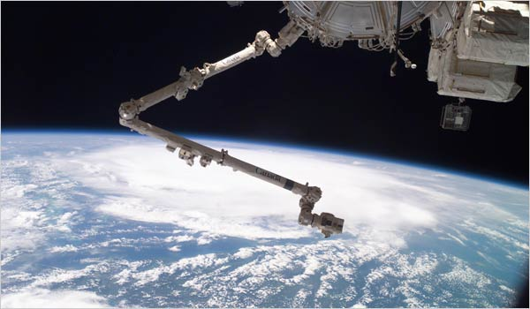

*Figure 2.* Robotic arm on the International Space Station.

Finally, the space station includes several laboratories for scientific experiments. The Japanese module (*Kibo*) includes an external platform for experiments that require exposure to actual space, and four more external docks are available for experiments (Figure 3). The external platform is nearly square (5m x 5.2m) and weighs 4.1 tons (Exposed facility, 2014). Fusce posuere, magna sed pulvinar ultricies, purus lectus malesuada libero, sit amet commodo magna eros quis urna. Nunc viverra imperdiet enim. Fusce est. Vivamus a tellus. Pellentesque habitant morbi tristique senectus et netus et malesuada fames ac turpis egestas. Proin pharetra nonummy pede. Mauris et orci. Aenean nec lorem.

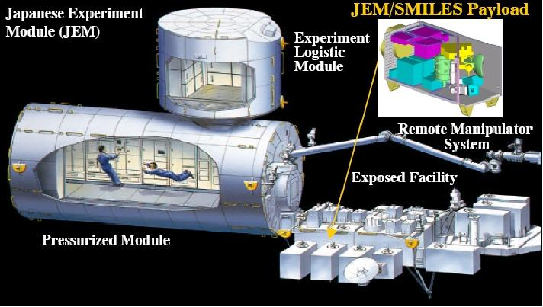

*Figure 3.* The Japanese Experiment Module.

The International Space Station is a remarkable collective effort by the United States, Japan, Russia, Canada and the European Union that has produced a huge amount of research and inspiration. It consists of many components, including the solar panels, the robotic arm, and the various experiment modules and platforms. These all are part of the spectacular progress of space exploration, which has developed from early rockets to the Moon landings and on to the many probes hurtling through space.

**References**

Canadarm2’s data sheet. (2018). Retrieved January 19, 2019, from http://www.asc-csa.gc.ca/eng/iss/canadarm2/data-sheet.asp

Exposed facility. (2014). Retrieved January 19, 2019, from http://iss.jaxa.jp/en/kibo/about/kibo/jef/

Garcia, M. (2017). About the space station solar arrays. Retrieved January 19, 2019, from https://www.nasa.gov/mission_pages/station/structure/elements/solar_arrays-about.html

Space Station. (1999). Retrieved January 19, 2019, from https://www.pbs.org/spacestation/station/components.htm