Cleopatra and the Languages of Ancient Egypt

Sakiko Suzuki

English Core II-A

Dr. Elwood

May 22, 2019

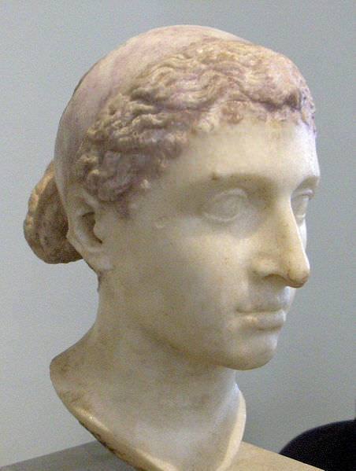I chose to focus on Cleopatra and the languages of ancient Egypt. Cleopatra remains one of the most famous of the Egyptian rulers and has been the subject of considerable research and several movies. She was believed to have been a beautiful woman, but her true charm may have been in her style of speaking and in her pursuit of power. As queen of Egypt, she was situated in Cairo, which has long been located at a crossroads geographically, lying on the Mediterranean Sea with Europe to the north, Africa to the south and west, the Arabian Peninsula to the east. This configuration certainly contributed to its linguistic heritage, of which Cleopatra was an interesting example.

Bust of Cleopatra. Photo courtesy of Louis le Grand (2012).

As noted above, Cleopatra was known for her skill with language. Her native language was Greek, which reflected her Greek ancestry. She was also proficient in Egyptian and likely spoke or at least knew several other languages. The Egyptian language of that time was the so-called Demotic form, whose written form included both hieroglyphs from the delta region in Egypt and also letters from the Greek alphabet (“Writing in Egypt”, 2002). Interestingly, Demotic Egyptian exists even today in the 21st century in the Coptic language used in religious ceremonies and by a very small number of fluent speakers (Gamil, 2017).

Spread to life a variety of individuals not only in the economic world, individuals are distributed internationally, to international activities, and participation has been brought. Have expanded the possibility that anyone can play an active role in the world.

In addition, it is required in solving the global challenges facing humanity, including global environmental issues, the wisdom of mankind. Under these circumstances, along with a wide field of view, the international community to live constantly, international understanding and cooperation has become essential. And, globalization, increased opportunities to touch the goods and services spread to life a variety of individuals not only in the economic world, individuals are distributed internationally, to international activities, and participation has been brought. Have expanded the possibility that anyone can play an active role in the world.

In addition, it is required in solving the global challenges facing humanity, including global environmental issues, the wisdom of mankind. Under these circumstances, along with a wide field of view, the international community to live constantly, international understanding and cooperation has become essential. And, globalization, increased opportunities to touch the goods and services spread to life a variety of individuals not only in the economic world, individuals are distributed internationally, to international activities, and participation has been brought. Have expanded the possibility that anyone can play an active role in the world.

References

Gamil, M. (2017, August 8). Coptic: Ancient language still spoken today. Retrieved May 12, 2019, from http://www.egypttoday.com/Article/4/16207/Coptic-Ancient-language-still-spoken-today

le Grand, L. (2012, April 26). Bust of Cleopatra. Ancient History Encyclopedia. Retrieved May 12, 2019, from https://www.ancient.eu/image/318/

Lights in street lamps. (1898, June 20). *The New York Times.* Retrieved January 22, 2013, from http://select.nytimes.com/gst/abstract.html?res= F10F11FD3B5811738DDDA90A94DE405B8885F0D3

Writing in Egypt: Demotic. (2002). Retrieved May 12, 2019, from https://www.ucl.ac.uk/museums-static/digitalegypt/writing/demotic.html