*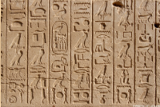Some questions for your consideration—please jot down brief answers to the following questions (either on paper or on your computer).*

1. What does this picture show? 🡪

2. In this picture you see the remnants of an ancient method of recording language. Jot down how you have recorded language in the last week or so (note that this can be either written or spoken language).

3. What does the word *artifact* mean?

4. What comes to mind when you hear that word?

5. Write down 2-3 examples of artifacts that are permanent (or nearly so).

6. Imagine that you are in your 70s or 80s and want to leave some artifacts from your lifetime for your grandchildren. What things would you leave for them?

7. What are *World Heritage Sites*? Name several examples.

8. Just for fun: how many World Heritage Sites are there?

9. Would you classify this image of Doraemon as an artifact? Why or why not?