## Name: ______________________

## Student # ___________

## Score _______ / 100

***You may use your notes, textbook, etc., but no talking with other people, please.***

**A. Word Bank 15 pts**

1. In the Word Bank, you included *parts of speech*. What are two kinds? **6**

2. You also had to write the context of each word. What does *context* mean? **3**

3. Where did you find most of your vocabulary words? **3**

4. Please explain what *collocation* means. **3**

**B.** **Comprehension** **Questions (**answer **four** of the following questions) **12 pts**

1. Who was Cleopatra?

2. Why was the city of Alexandria famous in the ancient world?

3. In our textbook we learned about a small ship called a dhow. Although it originated in the Middle East, it sometime sailed quite far away—where?

4. What is the purpose of the Dark Skies Movement?

5. The goals of the Slow Food Movementinclude supporting food that is __________, ___________, and ___________.

5. We read about two types of telescopes. What was one type? (Bonus: what was the second type?)

**C. Report Format 14 pts**

A. on the first page (the “title page”) of a written report, you should include five things. Of course, one is the **title**. What are the other four? **8**

B. Dr. Elwood suggested line spacing (行間) should be either ____ or ____. **2**

C. Double-sided printing (両面印刷) is fine for Dr. Elwood’s class—true or false?

D. What font type should you use for reports in this class? (Circle one answer) **2**

Comic Sans MS Century Times New Roman

**D. Vocabulary**—Match each vocabulary word with an appropriate definition.**44 pts**

____ thing used to make or repair something

____ a thing or things you can see in a museum

____ a picture of someone or something

____ not cooked

____ as much as possible, one hundred percent

____ govern or lead a country

____ how large or small something is

____ to arrive at a place, a level, or an amount

____ to watch carefully in order to learn something

____ to send back from a surface

____ a scientific instrument used for collecting information

____ part of a group

____ not long ago

____ find a new thing

____ thing you can see or touch

____ think about and then make something new

____ light that seems to become stronger and weaker

____ to see something in your mind, not with your eyes

____ used about food that is good for you

____ to look at or see something

____ to let someone do something, to grant permission

____ needed in order for something else to happen

1. recently

2. discover

3. completely

4. view

5. reach

6. nutritious

7. observe

8. necessary

9. rule

10. object

11. image

12. size

13. tool

14. atmosphere

15. twinkle

16. reflect

17. last

18. exhibit

19. probe

20. collapse

21. allow

22. gravity

23. imagine

24. raw

25. invent

26. appear

27. among

**Note: Yes, there are five extra vocabulary words ☺**

**E. Polite Email –** Write a polite email to ask about the homework you missed because you were absent from the last class. Your teacher’s address is myenglishteacher@aoyama.jp 12 **pts**

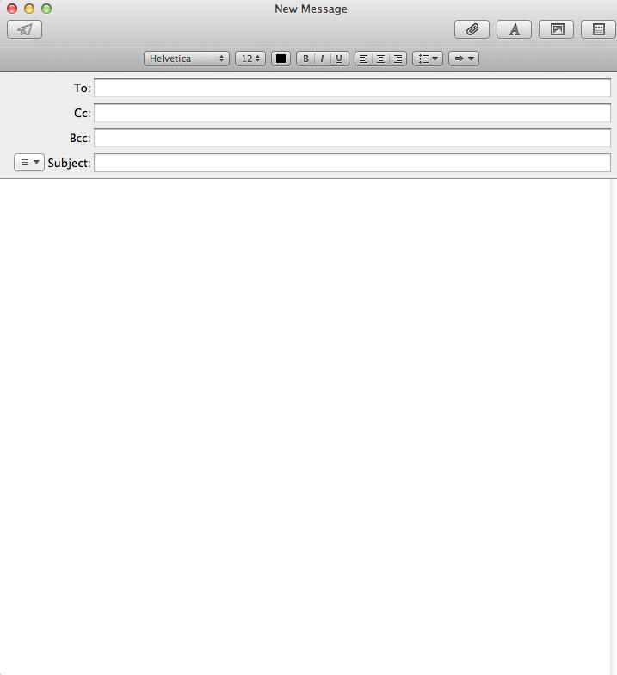

[Write your message here.]

Your final question: You want to send your homework as an email attachment. What would be a good filename for homework about your summer vacation plans?**3 pts**

*Have a good summer vacation!*