**A Land Without Guns: How Japan Has Virtually Eliminated Shooting Deaths**

By Max Fisher

July 23, 2012

*In part by forbidding almost all forms of firearm ownership, Japan has as few as two gun-related homicides a year.*

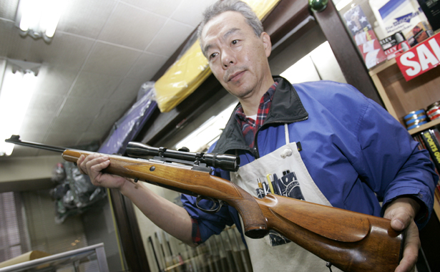

A Tokyo "gun" shop owner, who mostly sells air rifles, displays one of Japan's relatively few licensed rifles. (Reuters)

I've heard it said that, if you take a walk around Waikiki, it’s only a matter of time until someone hands you a flyer of scantily clad women clutching handguns, overlaid with English and maybe Japanese text advertising one of the many local shooting ranges. The city's largest, the Royal Hawaiian Shooting Club, advertises instructors fluent in Japanese, which is also the default language of its website. For years, this peculiar Hawaiian industry has explicitly targeted Japanese tourists, drawing them away from beaches and resorts into shopping malls, to do things that are forbidden in their own country.

Waikiki’s Japanese-filled ranges are the sort of quirk you might find in any major tourist town, but they're also an intersection of two societies with wildly different approaches to guns and their role in society. Friday's horrific shooting at an Aurora, Colorado, movie theater has been a reminder that America's gun control laws are the loosest in the developed world and its rate of gun-related homicide is the highest. Of the world's 23 "rich" countries, the U.S. gun-related murder rate is almost 20 times that of the other 22. With almost one privately owned firearm per person, America's ownership rate is the highest in the world; tribal-conflict-torn Yemen is ranked second, with a rate about half of America's.

But what about the country at the other end of the spectrum? What is the role of guns in Japan, the developed world's least firearm-filled nation and perhaps its strictest controller? In 2008, the U.S. had over 12 thousand firearm-related homicides. All of Japan experienced only 11, fewer than were killed at the Aurora shooting alone. And that was a big year: 2006 saw an astounding two, and when that number jumped to 22 in 2007, it became a national scandal. By comparison, also in 2008, 587 Americans were killed just by guns that had discharged accidentally.

Almost no one in Japan owns a gun. Most kinds are illegal, with onerous restrictions on buying and maintaining the few that are allowed. Even the country's infamous, mafia-like Yakuza tend to forgo guns; the few exceptions tend to become big national news stories.

Japanese tourists who fire off a few rounds at the Royal Hawaiian Shooting Club would be breaking three separate laws back in Japan -- one for holding a handgun, one for possessing unlicensed bullets, and another violation for firing them -- the first of which alone is punishable by one to ten years in jail. Handguns are forbidden absolutely. Small-caliber rifles have been illegal to buy, sell, or transfer since 1971. Anyone who owned a rifle before then is allowed to keep it, but their heirs are required to turn it over to the police once the owner dies.

The only guns that Japanese citizens can legally buy and use are shotguns and air rifles, and it's not easy to do. The process is detailed in David Kopel's landmark study on Japanese gun control, published in the 1993 Asia Pacific Law Review, still cited as current. (Kopel, no left-wing loony, is a member of the National Rifle Association and once wrote in National Review that looser gun control laws could have stopped Adolf Hitler.)

To get a gun in Japan, first, you have to attend an all-day class and pass a written test, which are held only once per month. You also must take and pass a shooting range class. Then, head over to a hospital for a mental test and drug test (Japan is unusual in that potential gun owners must affirmatively prove their mental fitness), which you'll file with the police. Finally, pass a rigorous background check for any criminal record or association with criminal or extremist groups, and you will be the proud new owner of your shotgun or air rifle. Just don't forget to provide police with documentation on the specific location of the gun in your home, as well as the ammo, both of which must be locked and stored separately. And remember to have the police inspect the gun once per year and to re-take the class and exam every three years.

Even the most basic framework of Japan's approach to gun ownership is almost the polar opposite of America's. U.S. gun law begins with the second amendment's affirmation of the "right of the people to keep and bear arms" and narrows it down from there. Japanese law, however, starts with the 1958 act stating that "No person shall possess a firearm or firearms or a sword or swords," later adding a few exceptions. In other words, American law is designed to enshrine access to guns, while Japan starts with the premise of forbidding it. The history of that is complicated, but it's worth noting that U.S. gun law has its roots in resistance to British gun restrictions, whereas some academic literature links the Japanese law to the national campaign to forcibly disarm the samurai, which may partially explain why the 1958 mentions firearms and swords side-by-side.

Of course, Japan and the U.S. are separated by a number of cultural and historical difference much wider than their gun policies. Kopel explains that, for whatever reason, Japanese tend to be more tolerant of the broad search and seizure police powers necessary to enforce the ban. "Japanese, both criminals and ordinary citizens, are much more willing than their American counterparts to consent to searches and to answer questions from the police," he writes. But even the police did not carry firearms themselves until, in 1946, the American occupation authority ordered them to. Now, Japanese police receive more hours of training than their American counterparts, are forbidden from carrying off-duty, and invest hours in studying martial arts in part because they “are expected to use [firearms] in only the rarest of circumstances,” according to Kopel.

The Japanese and American ways of thinking about crime, privacy, and police powers are so different -- and Japan is such a generally peaceful country -- that it's functionally impossible to fully isolate and compare the two gun control regiments. It's not much easier to balance the costs and benefits of Japan's unusual approach, which helps keep its murder rate at the second-lowest in the world, though at the cost of restrictions that Kopel calls a "police state," a worrying suggestion that it hands the government too much power over its citizens. After all, the U.S. constitution's second amendment is intended in part to maintain “the security of a free State” by ensuring that the government doesn't have a monopoly on force. Though it’s worth considering another police state here: Tunisia, which had the lowest firearm ownership rate in the world (one gun per thousand citizens, compared to America’s 890) when its people toppled a brutal, 24-year dictatorship and sparked the Arab Spring.

Retrieved from http://www.theatlantic.com/international/archive/2012/07/ a-land-without-guns-how-japan-has-virtually-eliminated-shooting-deaths/260189/