Wednesday, March 13, 2013

Music …

Your **final research project** (the questionnaire, etc.)

Similar form for the final research presentation and report …

1. Introduction
2. General background information about the topic (“literature review”)
3. Research questions: exactly **what** are you investigating?
4. Methods: **how** are you investigating those questions? (participants, questionnaire)
5. Results & discussion (meaning of results?)
6. Conclusion (final remarks, impression or opinion)
7. References 🡺 bibliographic information, the source(s)

“Table of Contents” slide: the main parts

Our task now: meet with me to discuss your research questions. When you’re NOT talking with me, work on your questionnaire, perhaps begin making your PowerPoint or your written report, …

My Grandfather’s clock

http://youtu.be/-U3YHsNrwtc

Wednesday, PM

With your group members, please discuss the following:

1. How much do you drink sugary drinks like Coca-Cola?
2. Your opinion about 40-oz. soda …
3. Government should limit the size of sugary drinks. Agree or disagree?

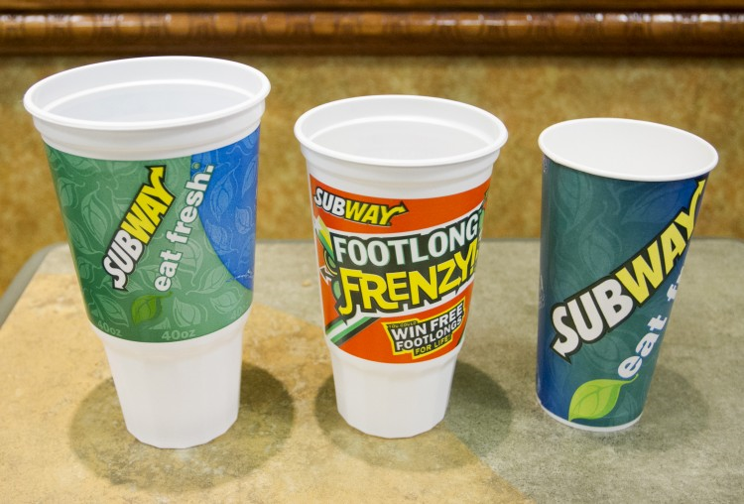

John Stuart Mills

“the greatest possible good”

Deadline for written report: by Thursday, March 21

Filename?

suzuki_tanaka_yamazaki_suzuki_gas_streetlights_2013.03.18

Tomorrow’s class(es): I have to leave early, so …