Gas Streetlights

Suzuki Sakiko

Tanaka Chiho

Yamazaki Hanae

Suzuki Yuko

Intensive English (Spring)

Dr. Elwood

March 17, 2013

**Introduction**

Today, the globalization has progressed rapidly in various aspects of the economy and society (“A Report”, 2011). Accordingly, the flow of people, not only the flow of goods, cross-border movement of information, such as capital becomes active, he has deepened international interdependence. In addition, intensified international economic competition, a condition called mega-competition has arrived. Then, there is a need for this bold challenge.

In addition, it is required in solving the global challenges facing humanity, including global environmental issues, the wisdom of mankind. Under these circumstances, along with a wide field of view, the international community to live constantly, international understanding and cooperation has become essential. And, globalization, increased opportunities to touch the goods and services spread to life a variety of individuals not only in the economic world, individuals are distributed internationally, to international activities, and participation has been brought. Have expanded the possibility that anyone can play an active role in the world.

**Literature Review**

In addition, it is required in solving the global challenges facing humanity, including global environmental issues, the wisdom of mankind. Under these circumstances, along with a wide field of view, the international community to live constantly, international understanding and cooperation has become essential. And, globalization, increased opportunities to touch the goods and services spread to life a variety of individuals not only in the economic world, individuals are distributed internationally, to international activities, and participation has been brought. Have expanded the possibility that anyone can play an active role in the world.

In addition, it is required in solving the global challenges facing humanity, including global environmental issues, the wisdom of mankind. Under these circumstances, along with a wide field of view, the international community to live constantly, international understanding and cooperation has become essential. And, globalization, increased opportunities to touch the goods and services spread to life a variety of individuals not only in the economic world, individuals are distributed internationally, to international activities, and participation has been brought. Have expanded the possibility that anyone can play an active role in the world.

**Research Questions**

1. What perceptions do people have about different music genres?
2. How do people listen to music?
3. …

**Methodology**

By the middle of the nineteenth century, gas street lamps were becoming increasingly common. In Sheffield in the UK, for example, some 1000 street lamps had been erected by 1850. However, gas street lamps had a short history. By the turn of the century, in cities such as New York, gas street lamps were being replaced with electric street lamps (“Lights in street lamps”, 1898). This process continued for many years with some gas streetlights remaining in use as late as 1958 in parts of New York (“Old gas street lamps fading”, 1958).

**Results & Discussion**

Under such circumstances, in order to survive in the 21st century, that the communication skills of English as an international common language is essential. English plays a central role in most international common language that connects 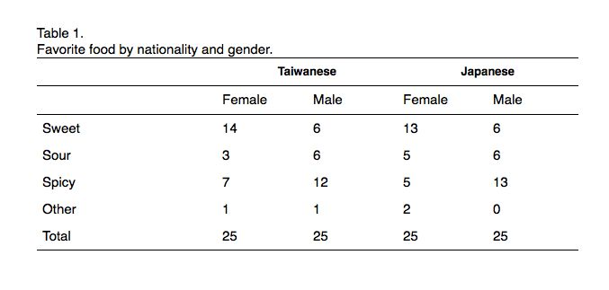between people of different native language.

English is very important language but also to connect with the world, understanding from the world, and is trusted to enhance 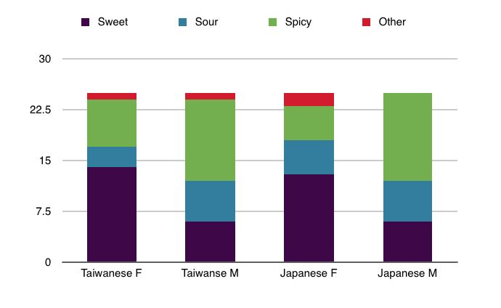the international presence, we will further develop.

*Figure 1.* Taste perceptions of Taiwanese and Japanese university students.

**Conclusion**

Under such circumstances, in order to survive in the 21st century, that the communication skills of English as an international common language is essential. English plays a central role in most international common language that connects between people of different native language. English is very important language but also to connect with the world, understanding from the world, and is trusted to enhance the international presence, we will further develop.

**References Cited**

Anderson, J. M., & Saby, J. S. (1979). The electric lamp: 100 years of applied physics. *Physics Today, 32*(10), 32-43. doi: 10.1063/1.2995240

Bouman, M. J. (1987). Luxury and control: The urbanity of street lighting in nineteenth-century cities. *Journal of Urban History, 14*(1), 7-37.

Cryer, P. (n.d.). Council-owned streetlights. Retrieved January 16, 2013, from http://www.1900s.org.uk/1900s-street-lighting.htm

Jeary, P. (2013, December 26). Warm glow of Berlin's 'beautiful' gas streetlights set to fade. Retrieved January 16, 2013, from http://worldnews.nbcnews.com/_news/ 2012/12/26/16017872-warm-glow-of-berlins-beautiful-gas-streetlights-set-to-fade?lite

Lights in street lamps. (1898, June 20). *The New York Times.* Retrieved January 22, 2013, from http://select.nytimes.com/gst/abstract.html?res= F10F11FD3B5811738DDDA90A94DE405B8885F0D3

Minding the streets: Lighting up. (2003). Retrieved January 16, 2013, from http://www.cityofsydney.nsw.gov.au/history/sydneystreets/Minding_the_Streets/Lighting_Up/default.html

Old gas street lamps fading as East Orange goes electric. (1958, November 19). *The New York Times*.Retrieved January 22, 2013, from http://select.nytimes.com/gst/abstract.html?res=F10C11F8385B117A93CBA8178AD95F4C8585F9

Sauter, V. L. (2012). *Street lights of the world.* Scotts Valley, CA: CreateSpace Independent Publishing Platform.

Schivelbusch, W. (1995). *Disenchanted night: The industrialization of light in the nineteenth century*. Ewing, NJ: University of California Press.

Shively, B., & Ferrare, J. (2011). *Understanding today's natural gas business.* Laporte, CO: Author.