Making a Google Map
Nothing difficult here, people!

Task. Our purpose is to describe things at and near the university. Your homework (did everyone complete it?) was to take a photo and send it to me (so I could resize it). Today you will actually make the map ☺

Step 1: Go to Google...
First you will go to Google at www.google.com

Next, click on Maps.

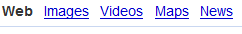

You will see a page that looks like this (probably!). In the upper, righthand corner you’ll Sign in

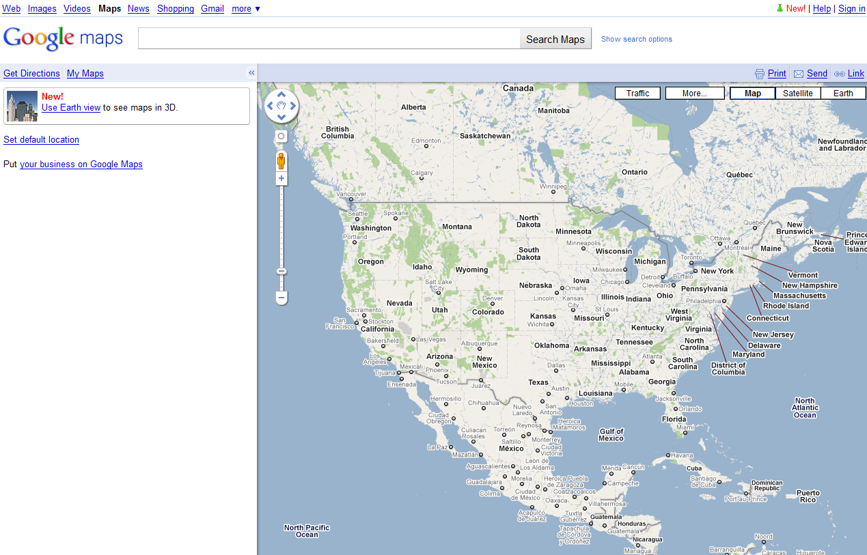

Yes, click that link and you’ll see…

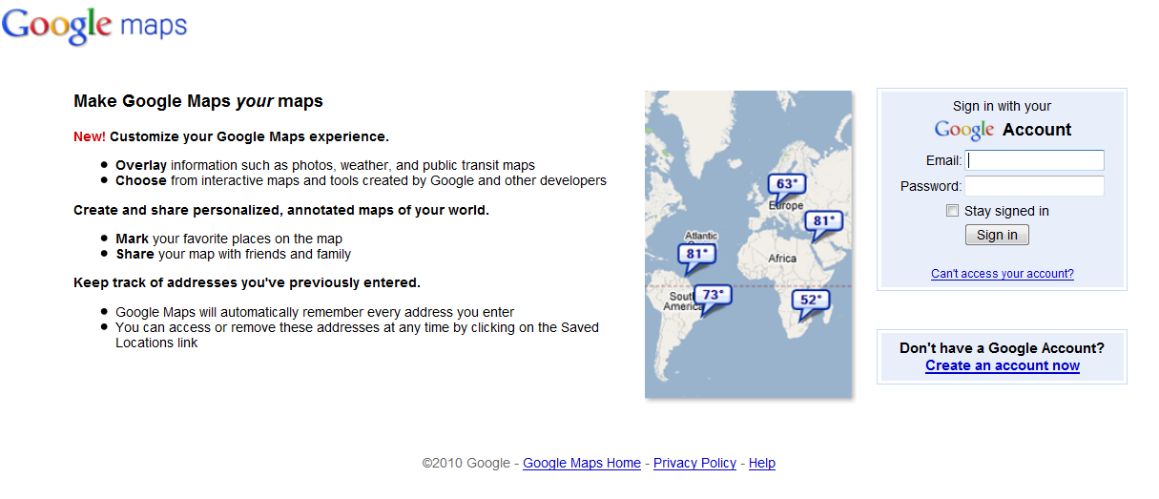

Next you’ll log in (wow). We will use Gmail account to edit our class map.

Login name: tgaku.student.##
Password: map4everybody

I will give you an account number (##). Everyone has the same password; please do NOT change the password. (If you have a gmail account, you may use that, but please tell me so I can invite you to our class map.)

Now you’ll see this page. Click My Places …

…and you’ll see this…

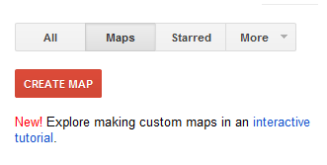
Cleverly, you’ll then click “create map” to begin making a new map.

You’ll see this page…

Then you’ll click the Edit button…

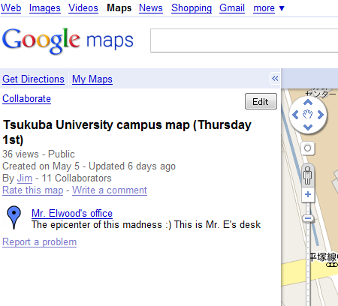

…to arrive here. To add your place, you’ll click the blue balloon…

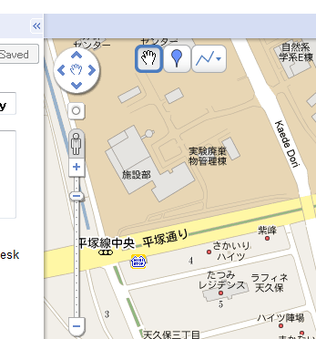

When you click the blue balloon, you’ll can move the blue balloon to the correct place (yes, you can move it later).

In the picture below, I put one on the main library…

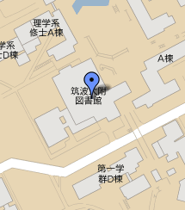

Then click the blue balloon and write your description!

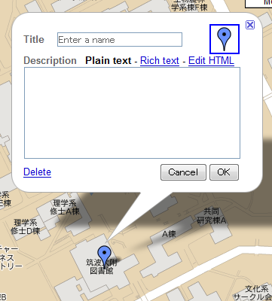

When you are finished, click OK and then Save or Done. If you want to add another balloon, then use Save and add another blue balloon.

Step 2: Your Photo
To add your photo, you’ll need to again click Edit…

Then the Rich text link…

You’ll see the photo icon here…

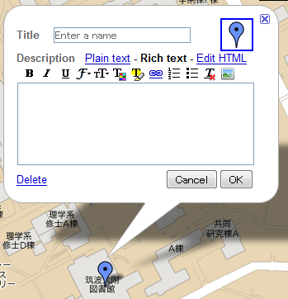

Here you’ll enter the path to your photo…

1. First, ask me about the name of your photo (“May I ask the name of my photo, please?”)
2. Next, you’ll add the path to your photo in this box…

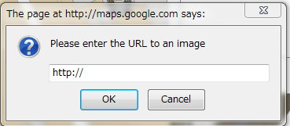

Just add the photo name in the empty place ☺

http://www.jimelwood.net/students/english_2/map_photos/______.jpg

When you’re finished, click OK, of course.

If you want more color (!), click on the blue balloon mark here… （笑）

Of course, when you’re finished, click OK / Save / Done …

Finally, how can you look at this map?

You could

1. use the gmail account,
2. search Google Maps, or
3. click the link on our class webpage!

