Earl Twigglesworth

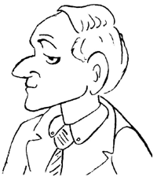
Spencer Twigglesworth is in his 70s and in very good health although his hearing isn't very good (especially when his wife is talking). He enjoys a glass of good brandy in his den, playing bridge, chatting with his old war buddies, hunting pheasants, and walking his dogs. He served in both France and the Pacific during the war, so he speaks French and very much likes Japanese things. His wife calls him "Spencer Dear," a phrase he doesn't really like, but they’ve been married so long he doesn’t complain!

Lady Twigglesworth
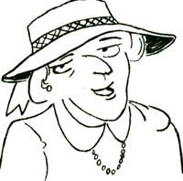
Hildegard Twigglesworth is also in her 70s and in good health. She likes to talk very much, and often she talks with her friends for many hours in the sunroom or on the veranda. She has many friends in Twigglesworth- on-Avon and is a member of many societies and clubs. Long ago she was a teacher known for her fun classes, and she still keeps in contact with many of her students. Her passion in life is pastries, especially those baked by their cook, Stephane, and by her good friend, Bertha Nelson. All her friends call her, "Hildy," but her husband calls her, "My sweet petunia."

Twinkletoes, the cat
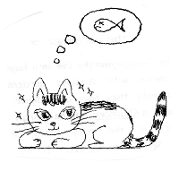
T-toes is, needless to say, fond of fish. She also likes toast, milk, and pastries, all of which she has nearly every day. Her favorite game is trying to catch the mice that hide in the kitchen, and she loves to “chat” on her cell phone (really, and no, I don’t know how a cat got a cell phone!).

