Presentation basics

Speaking: Organization / PowerPoint



Required parts:

1. **Title slide** – title, your name(s), your **affiliation**, the venue   
   (conference and the city), the date

総合数理学部 = Faculty of Interdisciplinary Mathematical Sciences

School of Interdisciplinary Mathematical Sciences

Date: write it out, please.

2016/10/29 🡺 October 29, 2016



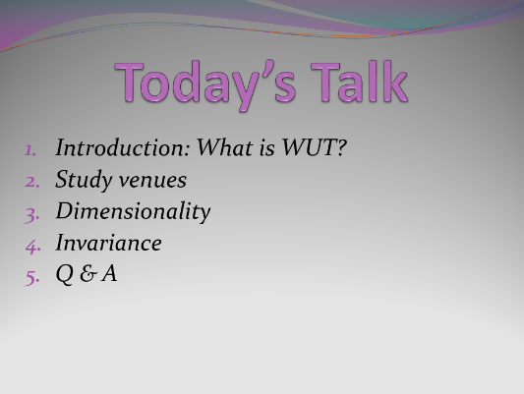

1. **Table of Contents (TOC) slide**
2. *Introduction (What is WUT?)*
3. *Study venues*
4. *Dimensionality*
5. *Invariance*
6. *Q & A*
7. **“chapter heading” slide** = name of one part

One slide says only, “1. Introduction: What is WUT?” … and

One slide says only, “2. Study venues”, and

…



1. **Questions**
2. **Thank you**
3. **References slide (if you have references!)**

PowerPoint tips:

F5 = start a presentation at the beginning

Shift + F5 = start at that slide

How to point out something on a slide?

* Use laser? 🡸 never ☹
* Use animation of shapes
* Use your hand?

Remote control 🡸 highly recommended

One more thing: If you use the keyboard, so do **quietly**, please!