Questions for discussion
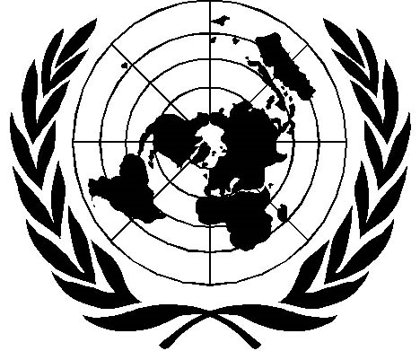
December 10, 2008

1. First, today is the 60th anniversary of something—what?
2. What are some of the things included there?
3. Recently there was a case in which an office in the SDF was criticized by the Japanese government for doing something. What did he do, and why was that a problem?
4. What’s your opinion of that action?
5. Let’s consider a famous court case from 1919, Schenck v. United States.
6. Do you agree with the decision?
7. Can you think of any similar examples in your home country?

