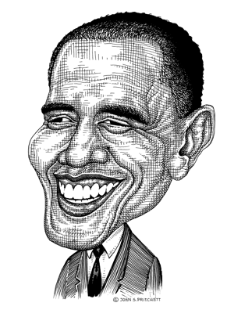
1. Is life a bowl of cherries or a journey? Why or why not?
2. Other examples of metaphors…
3. Stereotype—please write 2-3 examples and be prepared to explain them.
4. Can you think of any valid stereotypes?
5. What is one example of an erroneous stereotype?

Your homework: visit this website and find examples of five interesting cartoons.
http://cartoonbox.slate.com/index/

