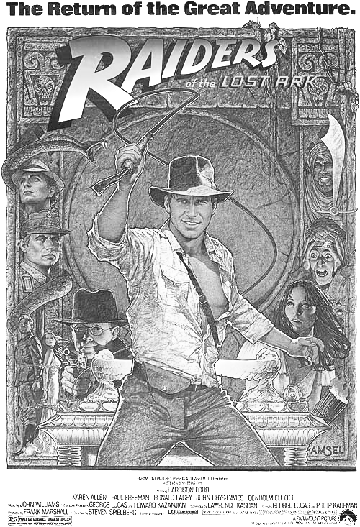
Greetings, all…today we’ll be talking about the canon of English. Actually, it might be of all languages…
1. First, think about the stories and literature in your native language. Are there some basic themes that occur repeatedly?
2. Next, are there differences between the oral and written traditions in your native language?
3. How about in your second or third language (i.e., in English or Japanese)?
4. As you’ll see shortly, in English there may be just seven basic plots… can you give me an example for each? (from any language would be fine)
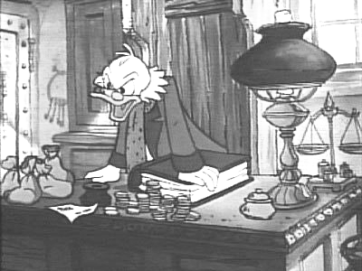
A. Voyage and return
B. A quest
C. Rags to riches

D. Comedy
E. Tragedy
F. Overcoming a monster
G. Rebirth
5. Are there any more categories?
6. The pictures are from which movies? Do those movies fit into any of the seven categories?
7. In manga, do we see any of these basic plots?
8. We’ve been talking about how different factors (e.g., historical, linguistic, social, religious, economic) influence events. Can you see examples of how these influence the seven categories posited here?

