1. Tables
a) The table is number like this: Table 1, Table 2, etc.
b) The title is italicized and in title case…for example:

Table 1
Rates of Greenhouse Gases in Major Cities in Japan
c) A table is “in-line” with the text (text is before and after the table)
d) Any explanation about the table should be included in the note at the end of the table.
e) If you use a table from a book, article, or the like, you must include the source in the note at the bottom of the table.
f) Notice that the source in the note is a different style than we’ve talked about in class.
g) “Note” is italicized, but the text in the note is regular font.
h) Notice that the lines are different weights (the top and bottom lines are heavier, thicker)
i) As shown in yellow, simply refer to the table or figure in the text or in parentheses.
2. Figures
a) Figure means anything other than a table (表): a picture, a graph, etc.
b) The ‘title’ (actually, the ‘caption’) is below the figure.
c) One major difference is that “Figure 1” is in italics and the title is not in italics (no, I have no idea why!)
d) The caption is in sentence case (i.e., only the first word and proper nouns are capitalized).

Figure 7. Annual CO₂ emissions from the non-renewable and the renewable systems.
In the following pages are some examples of tables and figures. Good luck, and please ask if you have any questions!
When renewable resources are made available, the optimal system configuration changes significantly (Table 1). Substantial wind and GHP capacity are introduced. In the renewable system 71% of the electricity comes from wind.
Table 1
System Capacity Configurations for Electric and Heat Systems
Component | Non-renewable (MW) | Renewable (MW)
Electric system
Peak grid electricity | 6.69 | 6.67
Wind | 0.00 | 9.64
PV | 0.00 | 0.01
Biomass | 0.00 | 0.07
Heat system
Petroleum | 17.87 | 16.69
GHP | 0.00 | 1.69
LPG | 0.00 | 0.00
Note. GHP = geothermal heat pump. From “Design for renewable energy systems with application to rural areas in Japan,” by T. Nakata, K. Kubo, and A. Lamont, 2005, Energy Policy, 33(2), p. 212. Copyright 2008 by Elsevier B. V. Reprinted with permission.

For the grid as a whole, large capacities of intermittent resources such as wind can create problems of stability and require larger amounts of spinning reserve. In Denmark, the share of wind generation is about 15% (Lund & Münster, 2003). Other studies have suggested that spinning reserve should not be a significant problem for wind penetrations below about 20% (Watson et al., 1994). Here the wind penetration is substantially higher which raises questions about …
CO₂ emission from renewable energy systems and the conventional energy system are shown in Figure 7. The emission factors of fossil fuels are based on the report published by the Japanese government (Ministry of the environment of Japan, 2000). As for the grid electricity, we have made reference to the report of electric utilities (The Federation of Electric Power Companies of Japan, 2002). The emission factors of petroleum, gas and grid electricity are shown in Table 1. In the conventional energy system, the annual CO₂ emissions are 7023 ton C/yr, while the annual CO₂ emissions in renewable energy systems are 3494 ton C/yr. The reduction of emissions from generation of grid electricity is the largest component of the reduction since substantial grid electricity is replaced by wind. In addition, about a quarter of the emissions from petroleum heat are eliminated by the GHP. Evaluating the total change in the CO₂ emissions due to both construction and operation of facilities would require a life cycle analysis. However, since the emissions from renewable energy sources are considerably lower than the emissions from fossil fuel fired stations, the impact on this evaluation would be small.
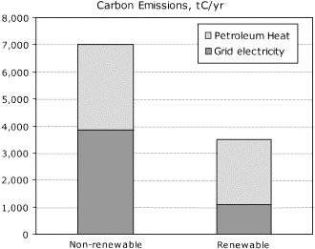
Figure 7
Annual CO₂ emissions from non-renewable and the renewable systems. From “Design for renewable energy systems with application to rural areas in Japan,” by T. Nakata, K. Kubo, and A. Lamont, 2005, Energy Policy, 33(2), p. 214. Copyright 2008 by Elsevier B. V. Reprinted with permission.

difficult than the first, the third more difficult than the second, and so forth). Fourth, the outfit mean statistics should be less than 2.0. Fifth, threshold calibrations should increase with the rating scale category. Finally, category thresholds should be separated as indicated in Table 7.
Table 7
Category Separation Series
Number of Likert scale  categories (j) |  | Series
 |  | ln(j) | ln(j) – ln(j-1) | Natural log series | Min sep (logits) | Min sep (CHIPS)
2 | .69 |  | .69 | 2.20 | 2.20 | 10.01
3 | 1.10 |  | .41 | 1.51ª | 1.4* | 6.37*
4 | 1.39 |  | .29 | 1.10 | 1.1* | 5.00*
5 | 1.61 |  | .22 | .81 | .81* | 3.69*
6 | 1.79 |  | .18 | .59 | .59 | 2.68
7 | 1.95 |  | .15 | .41 | .41 | 1.87
Note. Values with an asterisk are from Wolfe and Smith (2007, p. 210), and the corresponding CHIPS values are calculated from those data. ª If the value from the natural log series is used here in 3-category row, the minimum separation would be 1.51 logits (6.85 CHIPS) instead of 1.4 logits (6.37 CHIPS).
To the best of my knowledge, separation criteria are only available for 3-, 4-, and 5-category scales (Wolfe & Smith, 2007, p. 210). Inasmuch as the current study included 6- and 7-category scales, a more complete set of guidelines was necessary. Because the three values (i.e., 1.4, 1.1, and .81) are similar to a …
Intergroup Approach-Avoidance Tendency Subscale. On the revised International Approach-Avoidance Tendency subscale, WINSTEPS yielded poor category function with improperly ordered structure measures and inadequate separation. However, combining the categories yielded a 4-category alignment with proper ordering, good fit, and adequate spacing (Table 24).
Table 24
Category Function Statistics for the Revised Intergroup Approach-Avoidance Tendency Subscale
Approach-Avoidance category | Count (%) | Avg Measure | Exp Measure | Outfit MNSQ | Structure Measure | SE
Strongly avoid | 399 (17.66) | -6.10 | -5.98 | 1.05 | (none)
Avoid | 756 (32.43) | -2.10 | -2.21 | .93 | -6.95 | .29
Weakly approach | 791 (34.05) | 1.72 | 1.77 | .96 | -.50 | .23
Approach | 391 (17.86) | 6.96 | 6.95 | 1.12 | 7.45 | .31
Note. N = 252; Avg Measure = average measure; Exp Measure = expected measure.
On the revised Intergroup Approach-Avoidance Tendency subscale, the results from the WINSTEPS analysis indicated that all nine items had very good fit …
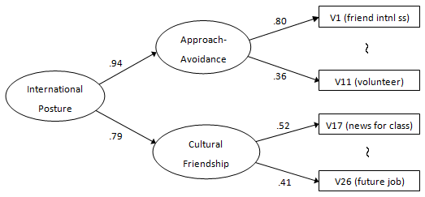
Figure 21. Standardized solution of the 2-factor International Posture instrument.
In addition, the 3-factor model of International Posture used in Yashima, et al. (2004) was analyzed and yielded the following fit statistics: χ² (87, N = 252) = …
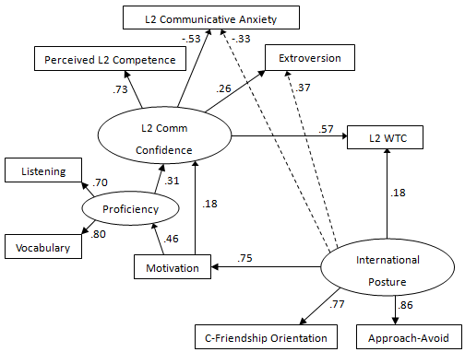
Figure 47. Standardized solution of the revised Yashima (2002) model. Numerical values indicate that path coefficients were significant at p < .01. χ²(21) = 44.31 (p < .01), CFI = .968, RMSEA = .067, 90% C.I. = .039-.094.
The standardized solution is shown in Figure 47. The hypothesized path from L2 Communicative Confidence to Extroversion was statistically significant (β = .26). The two data-driven additions from International Posture to Anxiety and Extroversion were fairly strong at -.33 and .37, respectively. With three exceptions, the original path coeffieients are similar to the original Yashima (2002) model …

