- Finally, we have a Monday class!
- For my 3rd period class, I’ll return most of your persuasive papers. This will take a few minutes because I would like to make some comments to individuals. When you’ve received your paper, please look at the corrections carefully.
- One point: for your persuasive paper(s), you must have references both in the text and in the reference section. Furthermore, the form should be correct now—you have, after all, many examples of correct references!
- A gentle reminder: Be careful of using emotions too much! Let’s look at a few examples of using logic / emotion…
- Abstracts
  - What? An abstract is a short statement or summary of your paper. It is at the beginning and includes your main points, your thesis, and any conclusions. It is usually written last, after your paper is finished.
  - An abstract appears on the Internet, in searches, etc.
  - For example, this paper (Yashima, 2002) is one I’ve quoted extensively.
  - Let’s visit Google Scholar or Google Scholar in Japanese
  - Here, of course, you can search for specific articles, authors, or subjects…
  - First, open a new Word document; next, find and copy the abstracts for the following three articles:
MacIntyre, P. D. (2007) Willingness to communicate in the second language: Understanding the decision to speak as a volitional process. The Modern Language Journal, 91(4), 564-576.
Root, T. L., Price, J. T., Hall, J. R., Schneider, S. H., Rosenzweig, C., & Pounds, J. A. (2003, January 2). Fingerprints of global warming on wild animals and plants. Nature, 421(6918), 57-60.
Shizuka, T., Takeuchi, O., Yashima, T., & Yoshizawa, K. (2007). A comparison of three- and four-option English tests for university entrance selection purposes in Japan. Language Testing, 23(1), 35-57.
  - Next, can you get the actual article? If so, please download the three articles.
  - A pdf of more abstract examples…
  - Student abstract examples…

The Vocational Education Program in Bolivia
This paper reports on a recent project for Vocational Education implemented in Bolivia during the past five years. The experimental project, based on a similar foreign program, was a failure because it was not adapted to Bolivians’ needs. This report evaluates the failure of the original project, demonstrates that the basic tenets of the plan were positive, and proposes adaptations to the project that will lead to a fine Vocational Educational system

The Effects of Carbon Monoxide
In this paper, the mechanism of carbon monoxide is described and the chemistry of carbon monoxide is presented. The most important aspect of carbon monoxide is examined: its possible catastrophic effects on the global environment. Some specific examples of these effects include those on the human fetus and heart, on vegetation, and on animals.

  - The form… The form is generally slightly different than the rest of the paper, but there is no one standard form. You may, for example, use italics. However, please do indent the abstract 1cm on both the left and right sides.
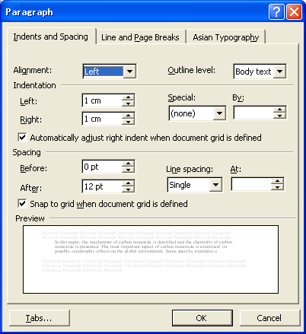
  - Note the absence of “I”… what is the grammar used above?
  - Your job: on your group persuasive paper, you must have an abstract.
  - After we talk about our upcoming schedule (see below), you may work on your group persuasive papers.
- Upcoming schedule…
Class #5. January 24 (today)
Class #6. January 31
Class #7. February 7
Class #8. February 14 (group persuasive paper due ⬅ our final class
February 21 (no class)
February 28 (no class)
March 7 (no class, no test)

Note: between February 15 and March 4, you and a partner (or you alone) will have to meet with me in my office. You will need to bring all of your papers, if possible.

