- Welcome back and Happy New Year!
- Individual persuasive papers should be finished by next class—sorry, but I’m still adding comments.
- Please hand in your descriptive paper.
- Two comments…
  - Be careful of beginning sentences with AND / BUT / SO / ALSO… several people have apparently forgotten about this.
  - The references should be very good now—you’ve seen many examples of correct forms and how to format them, so they should be good.
  - The beginning of a reference should be either the author or the name of the article. It should not be some large news company or the name of the webpage domain.
Wikipedia. (2010). Rain forests. Retrieved December 10, 2010, from www.widipedia.com/rainforests
Rain forests. (2010). Retrieved December 10, 2010, from www.widipedia.com/rainforests
- Review of upcoming papers
  - Group persuasive papers—
- Due by class #8 (February 14th – Valentine’s Day) … but, of course, I’ll happily accept your paper before then ☺. When you hand in your paper, you will need two copies of your paper: one is for me, and one is for your classmates (the “other side”). If you hand in just a computer file, then you’ll need to give that file to the “other side” people, too.
- Pro paper—two people write one paper
- Con paper—two other people write one paper
- On each title page, there will be names of two people.
  - You should keep all of your papers—remember that you will need them in February or March when you talk to me…
- Usage worksheet #3: miru
- Group persuasive paper worksheet

- Our upcoming schedule…
Class #5 – January 24
Class #6 – January 31
Class #7 – February 7
Class #8 – February 14 ⬅ our final class
February 21 (NO CLASS)
February 28 (NO CLASS)
March 7 (NO CLASS – final exam week)

Note: between February 15 and March 5, you and a partner (or you alone) will have to meet with me in my office. You will need to bring all of your papers, if possible.

In February and March, we will have no classes after February 14th. However, you will have homework, and there is the final meeting with me. Of course, we will have no final exam on March 7.

- Abstracts
  - What? An abstract is a short statement or summary of your paper. It is at the beginning and includes your main points, your thesis, and any conclusions. It is usually written last, after your paper is finished.
  - An abstract appears on the Internet, in searches, etc.
  - For example, this paper (Yashima, 2002) is one I’ve quoted extensively.
  - Let’s visit Google Scholar or Google Scholar in Japanese
  - Here, of course, you can search for specific articles, authors, or subjects…
  - First, open a new Word document; next, find and copy the abstracts for the following three articles:
MacIntyre, P. D. (2007) Willingness to communicate in the second language: Understanding the decision to speak as a volitional process. The Modern Language Journal, 91(4), 564-576.
Root, T. L., Price, J. T., Hall, J. R., Schneider, S. H., Rosenzweig, C., & Pounds, J. A. (2003, January 2). Fingerprints of global warming on wild animals and plants. Nature, 421(6918), 57-60.
Shizuka, T., Takeuchi, O., Yashima, T., & Yoshizawa, K. (2007). A comparison of three- and four-option English tests for university entrance selection purposes in Japan. Language Testing, 23(1), 35-57.

  - Next, can you get the actual article?
  - A pdf of more abstract examples…
  - Student abstract examples…

The Vocational Education Program in Bolivia
This paper reports on a recent project for Vocational Education implemented in Bolivia during the past five years. The experimental project, based on a similar foreign program, was a failure because it was not adapted to Bolivians’ needs. This report evaluates the failure of the original project, demonstrates that the basic tenets of the plan were positive, and proposes adaptations to the project that will lead to a fine Vocational Educational system

The Effects of Carbon Monoxide
In this paper, the mechanism of carbon monoxide is described and the chemistry of carbon monoxide is presented. The most important aspect of carbon monoxide is examined: its possible catastrophic effects on the global environment. Some specific examples of these effects include those on the human fetus and heart, on vegetation, and on animals.

  - The form… The form is generally slightly different than the rest of the paper, but there is no one standard form. You may, for example, use italics. However, please do indent the abstract 1cm on both the left and right sides.
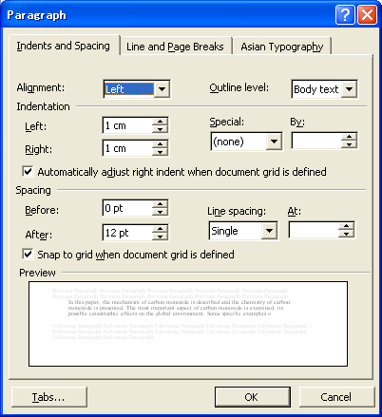
  - Note the absence of “I”… what is the grammar used above?
  - Your job: in your group persuasive paper, you must have an abstract.

