- Check your grade for the second term and ask me if you have questions.
- Let’s glance at the e-mail paper from last week.
- Next, let’s look at the office visit paper.
- Descriptive paper, due by our 4th class, January 18.
  - May describe anything (your room, a family member, the autumn leaves around Tsukuba, etc.)
  - Essay format with a title page
  - Use of both subjective and objective description
Subjective & Objective
Objective | Subjective
brown, leather-covered seats | the sickening smell of cheap beer and おつまみ
torn blue curtains | uncomfortable seats that belong in an old car
a look by his former girlfriend | the ice-cold stare of his ex-girlfriend
gray walls covered with fingerprints and graffiti | cold, gray walls pulsing with the untold stories of those nameless people, long forgotten except for their fingerprints and graffiti
used paper cups and cold popcorn scattered across the theater floor | the buzzing sound of the audience
a cold, windy evening in December | Snow swirled, becoming a maelstrom in the ghostly chill of the winter air
autumn leaves falling | Leaves twisting and turning restlessly on their first and final journey
the coffee cup on my desk | the Mr. Potato Head coffee cup on my desk, staring at me and laughing, just daring me to get any work done
a large rug with the image of an eagle on it (below) | a bold statement of a rug with its powerful, elegant eagle radiating strength
an usher asking the children to be quiet | an usher walking toward the noisy kids, yelling like a military officer

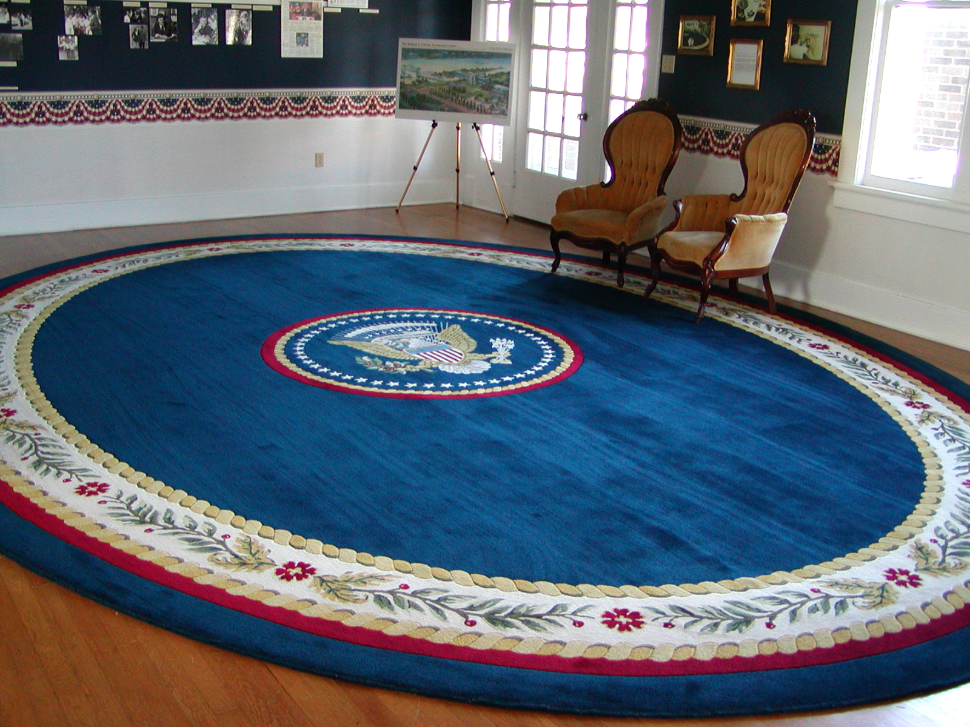
Comments on subjective language
      - Often subjective language depends on lexical choice…for example, how many different verbs can you think of for walk?
      - A second technique is personification (giving human qualities to a non-human thing)
  - Let’s first read some excerpts from A River Runs Through It
  - Next, we have a worksheet on A River Runs Through It
  - An example from Robert Frost…about a Road Not Taken
  - You might look again at the Four Seasons in Tsukuba essay
- Your homework for next week: please work on the worksheet for your descriptive paper. While I will not collect the worksheet, it is to help you with your descriptive paper. With our remaining time today, you may work on the worksheet or your descriptive paper.

