- Apologies for having had to cancel class last week on short notice (family stuff), but hope you enjoyed your holiday.
- Summer papers—
  - If you have not already done so, please hand in your summer paper.
  - One more time: when you send a computer file, the correct file name is
yourname_summer_paper_2010.09.22
my_summer_paper
Imagine Mr. E receiving many files named “summer vacation”…☹
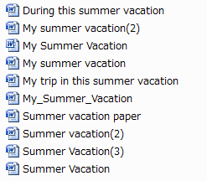

Now imagine Mr. E receiving many files with correct names … ☺
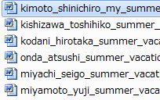

- Our first task today: please download the class notes from last week (2-2) and the Anne of Green Gables exemplar.
- Usage Worksheet #2: させる
- Cause & effect C & E vocabulary
- References
  - Used when you use an idea or words from another person or source…
  - Let’s look at a piece of my writing…
  - Correct forms of references / citations.

For references, you might also check these websites:

APA Style homepage:
http://apastyle.apa.org

The Owl at Purdue:
http://owl.english.purdue.edu/owl/resource/560/01

Long Island University’s APA Citation Style:
http://www.liunet.edu/cwis/cwp/library/workshop/citapa.htm

- The remaining time today is to be used to work on your Cause & effect paper.

