- Your “name” papers… still working on them (sorry!).
- Present perfect aspect
  - Three purposes: to show that there was an experience (したことがある), to show something that happened or began in the past and continues to influence the present, and to show change.
  - Experience:
I have visited New York three times.
We have never gone to Hawaii.
  - Past → present:
I have lived in Japan for 16 years. (I still do and the influence continues.)
I’ve already eaten. (Thus, I am still full and don’t want to eat more.)
I haven’t eaten yet. (Thus, I am hungry now.)
I have played piano since I was in elementary school. (and I still play)
  - Change (recently)
Recently many children in Japan have had less interest in science.
The number of people that travel abroad has decreased since the end of the bubble era in Japan.
Cases of violent crime have become more common over the last 10 years in Japan.
  - In your contemporary Japan paper, do you need present perfect?

- References—information from print or digital sources
  - Background
(1) Wikipedia in English
(2) Wikipedia in Japanese
  - Search engines
(1) Yahoo Japan
(2) Google in English
(3) Google in Japanese
  - Specific sources—notice that you can search for articles on these pages; the image is from the Washington Post homepage. ➔
(1) The Japan Times
(2) New York Times
(3) Washington Post

  - Note: in your papers, you may list Wikipedia only one time.
  - Note: sometimes when you access a Japanese webpage (e.g., the 温暖化page in Wikipedia Japan), the URL (the address) will copy like this:
http://ja.wikipedia.org/wiki/%E6%B8%A9%E6%9A%96%E5%8C%96
The end part (%E6%B8%A9%E6%9A%96%E5%8C%96) is the code for 温暖化. My suggestion is to use the original…
http://ja.wikipedia.org/wiki/温暖化
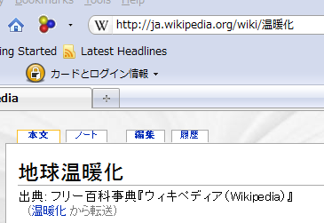
OR add the ローマ字 to help your reader ☺
http://ja.wikipedia.org/wiki/温暖化 [ondanka]
- Introductions…(intro explanation)
  - Purpose: to introduce your topic, make your reader interested, and state your main point (your thesis) VERY, VERY clearly
  - Should be a paragraph, so 5-8 sentences
  - Style exemplars
  - Write a good introduction for the following paper about Avoiding Science
- Contemporary Japan paper
  - Please hand in your contemporary Japan by June 28th (note that this day is during exam week, but we will have no exam).
  - Must be a computer paper, not handwritten
  - Must have a title page
  - Staple in the upper lefthand corner

