- Check homepage worksheet answers
- Basic paper format
  - Name: in ローマ字, order is your choice
  - Student number not necessary
  - Double spacing (format → paragraph → line spacing OR Ctrl + 5
  - Indentation: about 1.5cm page 2
  - Margins… “picture frame” page 3
  - If multiple pages, then staple in upper LEFTHAND corner
- Editing basics: mechanics
  - Spelling
  - Punctuation
  - Capitalization
  - Correction key
Let’s take a few minutes and check your self-introduction ☺
- Some computer tricks…
  - Selecting things… use edit menu OR clicking
double click (word) → triple click (paragraph)
  - Many keyboard “shortcuts”
Control + I → italics
Control + C → copy
Control + V → paste
- What’s a paragraph?
  - 5-8 sentences
  - ONE IDEA, ONE PARAGRAPH
  - Topic sentence / supporting sentences / concluding sentence
  - Topic sentence states the main idea (the topic) and “controls” that idea…
  - Supporting sentences add support (!)
  - The concluding sentence naturally reviews or restates the main idea of the paragraph.
  - Let’s look at page 6
- Essay format
  - Introductory paragraph
  - Three body paragraphs (parts)
  - Concluding paragraph
- Your homework
  - Check/revise your self-introduction
  - Again look at our homepage ☺
  - Topic sentence / supporting sentences / concluding sentence (similar to essay?)

Indentation

1 cm
Cell phones have changed the way we communicate. With a cell phone, we can call nearly anywhere—in other words, we have freedom to move. No longer are we confined to a single telephone location where the line comes out of the wall. In addition, we can communicate by using the e-mail function on cell phones. Even if the other person isn’t available, an e-mail can be easily sent for the other person to find. In the world of the twenty-first century, communication with cell phones is much different than the last century.
Margins…
- should be like a picture frame
- about 2.5cm

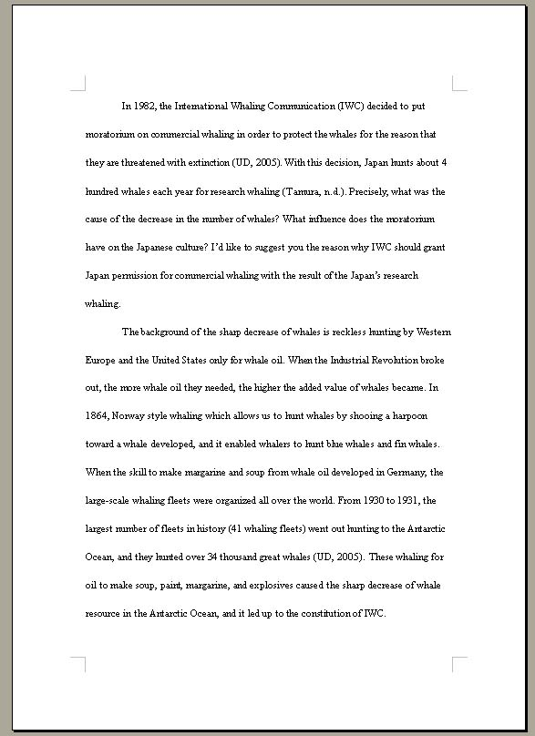

New vocabulary words?
functions
note-taking
brainstorming
paper format
double spacing
margins
staple
editing
mechanics
punctuation
capitalization
correction key
essay format
paragraph

Cell phones have changed the way we communicate. With a cell phone, we can call nearly anywhere—in other words, we have freedom to move. No longer are we confined to a single telephone location where the line comes out of the wall. In addition, we can communicate by using the e-mail function on cell phones. Even if the other person isn’t available, an e-mail can be easily sent for the other person to find. In the world of the twenty-first century, communication with cell phones is much different than the last century.
What’s a paragraph?
  - 5-8 sentence
How many sentences are there? ______
  - ONE IDEA, ONE PARAGRAPH
The one idea of this paragraph ________________________________
_________________________________________________________
  - Topic sentence / supporting sentences / concluding sentence
→ circle the topic sentence and the concluding sentence…
  - Topic sentence states the main idea (the topic) and “controls” that idea…
Main idea = __________________________________________
Control = ____________________________________________
  - Supporting sentences add support (!)
The support has two ideas…
(1) freedom to___________________________________________
(2) ____________________________________________________

  - The concluding sentence reviews or restates the main idea of the paragraph.
Write the concluding sentence here… ________________________________________________________
________________________________________________________

