(add an introduction)

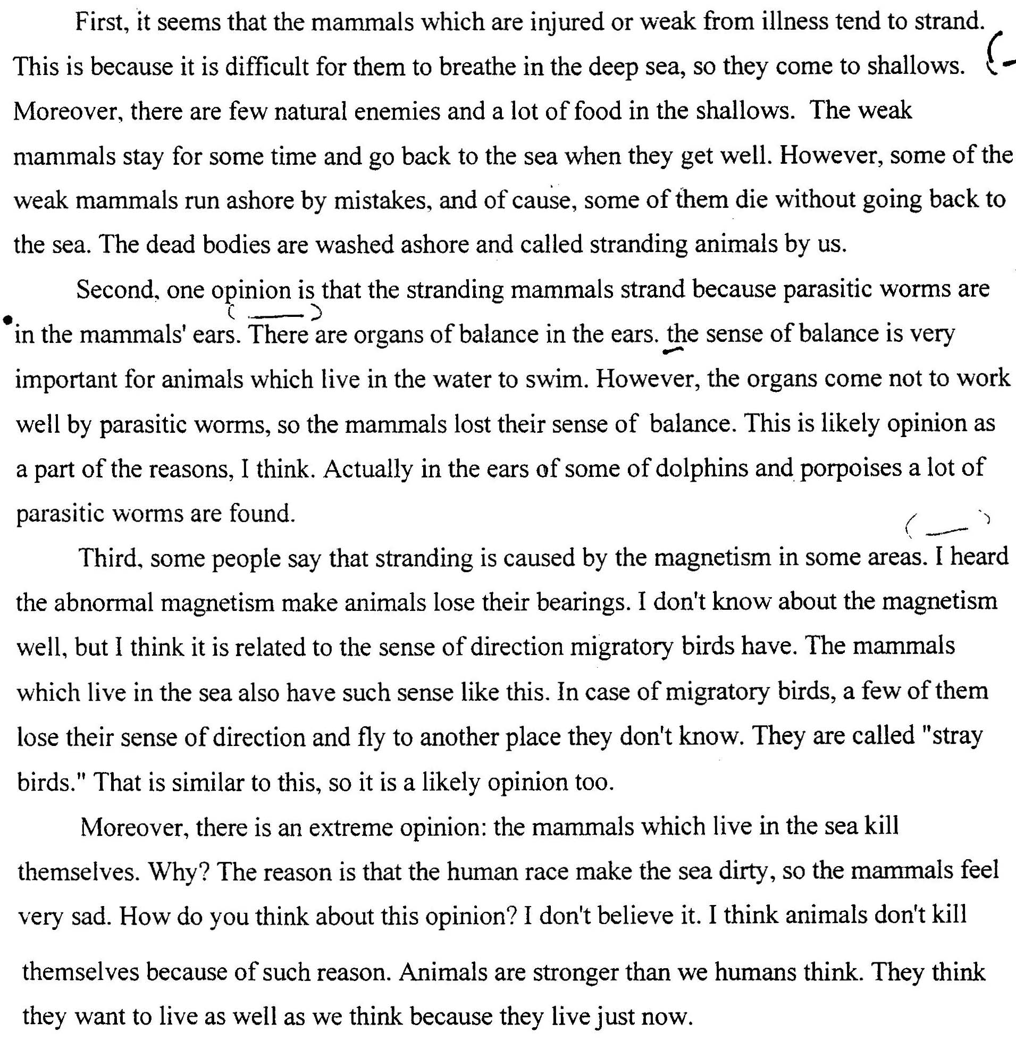

(add a conclusion)

