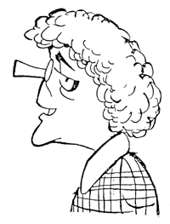
the local chef →
Bertha Nelson is a long-time resident of TOA and is locally famous for the delicious things from her pastry shop, Bertha’s Goodies. She and Hildegard Twigglesworth have been friends for many years, and they often drink afternoon tea together while chatting and eating pastries from Bertha’s shop. A little-known fact about Bertha is that she is a karate aficionado and often competes in tournaments.

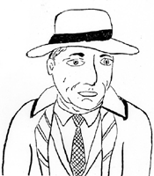
← the police chief
Of course, in TOA there is a police force, and its chief is Perry O’Mason. He’s a little man although he loves to eat (especially sweet things like pastries). He’s usually very careful in his work, and he has a reputation as an excellent policeman. In his spare time he enjoys watching movies, and his hero is Humphrey Bogart.

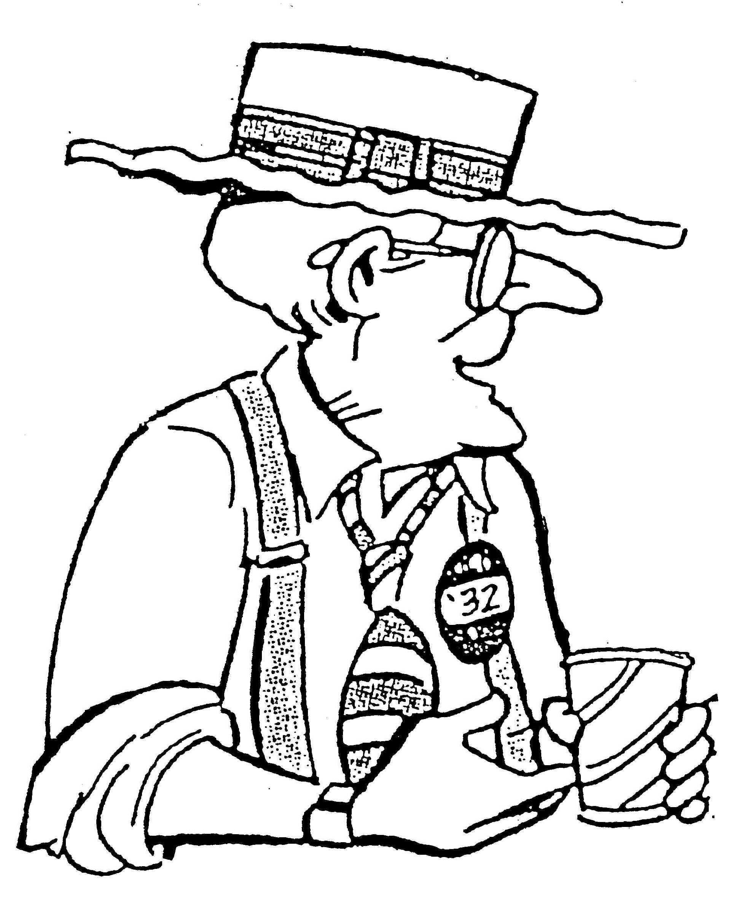
the senator →
So who is the strangest person in TOA? Probably that would be the Senator, an eccentric old politician who loves steak but has a vegetarian restaurant, who listens to rock and roll, and who does juggling as a hobby. Although he is a kind old fellow, he seems to have constant money problems, but sometimes his cousin (Earl T) helps him.

