Earl Twigglesworth

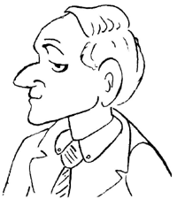
Spencer Twigglesworth is in his 70s and in very good health although his hearing isn't very good (especially when his wife is talking). He enjoys a glass of good brandy in his den, playing bridge, chatting with his old war buddies, hunting pheasants, and walking his dogs. He served in both France and the Pacific during the war, so he speaks French and very much likes Japanese things. His wife calls him "Spencer Dear," a phrase he doesn't really like, but they’ve been married so long he doesn’t complain!

Lady Twigglesworth
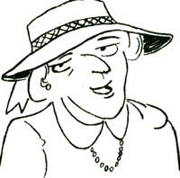
Hildegard Twigglesworth is also in her 70s and in good health. She likes to talk very much, and often she talks with her friends for many hours in the sunroom or on the veranda. She has many friends in Twigglesworth- on-Avon and is a member of many societies and clubs. Long ago she was a teacher known for her fun classes, and she still keeps in contact with many of her students. Her passion in life is pastries, especially those baked by their cook, Stephane, and by her good friend, Bertha Nelson. All her friends call her, "Hildy," but her husband calls her, "My sweet petunia."

Twinkletoes, the cat
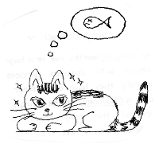
T-toes is, needless to say, fond of fish. She also likes toast, milk, and pastries, all of which she has nearly every day. Her favorite game is trying to catch the mice that hide in the kitchen, and she loves to “chat” on her cell phone (really, and no, I don’t know how a cat got a cell phone!).

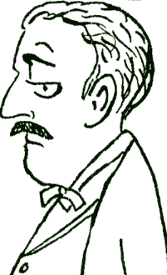
the butler →
Henry James is a traditional English butler. He has worked for the Twigglesworth family for many, many years, and they trust him very much. He is a master at clothing, and there isn’t a better butler to serve drinks and take care of guests. When he isn't working he enjoys collecting stamps and cooking (although the cook doesn’t like to share the kitchen).
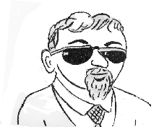
← the driver
Neither of the Twigglesworths can drive, so they employ a driver, Mike Nuvallo. He is a cousin of a famous racecar driver, and he loves the family cars, polishing and waxing them nearly every day. Sometimes he is rather short-tempered, but really he is very kind and gentle. His hobbies include Japanese flower arranging and ballet dancing.

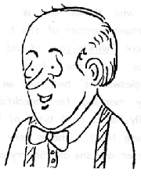
the gardener →
The Twigglesworths live in a huge, old mansion with spacious gardens, so naturally they have a gardener. His name is Chauncey, and he lovingly takes care of the many trees, shrubs, gardens, flowers, etc. His pride and joy is the family rose garden. Much of his work is done organically, as he worries about the environment. In his spare time he is a champion boxer.
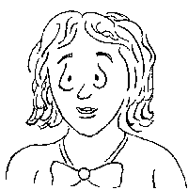
the maid →
Sherry Smith is the maid in the Twigglesworth house, and she keeps the mansion spotless. She cleans very carefully, repairs any broken things, and often has good ideas for improvements. She’s always a happy, smiling lady, and she enjoys knitting and watching American football on TV. She and Twinkletoes (the cat) are wonderful friends.

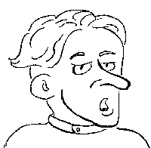
← the cook
Of course, in the Twigglesworth mansion there is a full-time cook. Stephane Lemond is French and a wonderful cook, especially of cakes and pastries. He is very, very particular about his kitchen, and he doesn’t like to share it with anyone! Earl T also speaks French, so they often enjoy chatting in French. In his spare time Stephane likes playing soccer and reading, mainly mystery and action novels.

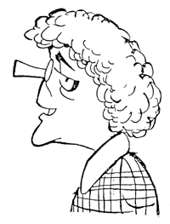
the local chef →
Bertha Nelson is a long-time resident of TOA and is locally famous for the delicious things from her pastry shop, Bertha’s Goodies. She and Hildegard Twigglesworth have been friends for many years, and they often drink afternoon tea together while chatting and eating pastries from Bertha’s shop. A little-known fact about Bertha is that she is a karate aficionado and often competes in tournaments.

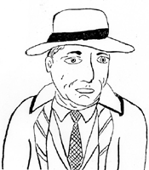
← the police chief
Of course, in TOA there is a police force, and its chief is Perry O’Mason. He’s a little man although he loves to eat (especially sweet things like pastries). He’s usually very careful in his work, and he has a reputation as an excellent policeman. In his spare time he enjoys watching movies, and his hero is Humphrey Bogart.

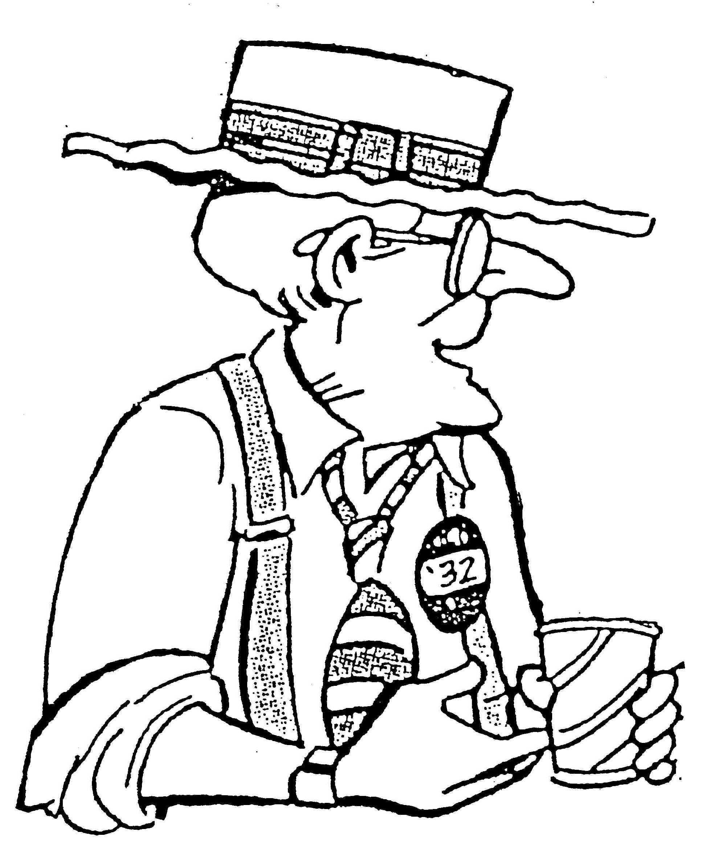
the senator →
So who is the strangest person in TOA? Probably that would be the Senator, an eccentric old politician who loves steak but has a vegetarian restaurant, who listens to rock and roll, and who does juggling as a hobby. Although he is a kind old fellow, he seems to have constant money problems, but sometimes his cousin (Earl T) helps him.

