Winter, 2007

Still only 50 cents!

Number 4
The Times
of

Twigglesworth-on-Avon

Health Inspectors Slam Door on Bertha’s!

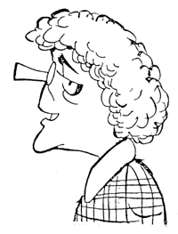
TOA—In the latest news twist in the mysterious disappearance of Lady Twigglesworth, local pastry chef Bertha Nelson, owner and chef at Bertha’s Goodies, has been forced to suspend business after a recent inspection found several serious violations of health laws. Ms. Nelson was shocked about the news, saying weakly , “I have always had suh a clean shop. I can’t imagine how they found something wrong,” Her lucrative pastry business, often a target of other local shops, can now be acquired by rival pastry shops or private chefs.

Mysterious Letter Found in Lady T’s Purse

Assistant Police Chief Poirot has quietly announced that a mysterious letter was found in the purse of Lady Twigglesworth. According to Poirot, “It appears to be in a foreign language that I don’t know. However, there were many hearts drawn on the paper, and I would guess it is some sort of love letter. When it has been translated, we will hold another press conference.”

Letters to the Editor

Dear Mr. Editor,
There is a menace loose in our community! I refer to the local chefs that claim to serve healthy food, but whose food is really deadly. Please, please, PLEASE don’t eat this dangerous food from local chefs!
Sincerely,
An anonymous gastronome

Dear Mr. Editor,
When will TOA people learn to keep their pets from bothering other people? Some new tenants near my house have some poor cat that constantly cries, and from the humans’ noise I think the cat may have attacked them. Far too noisy!
Sincerely,
Ear-Plug Man

From where I sit…the Editor Speaks…
Greetings to all you good people in TOA! Even in this cold weather, remember to take good care of yourself and keep warm, both insdie and out. This is a great time of year to remember those dear to you—so why not tell them now that they’re special? It won’t take but a minute to fire off a quick note or an e-mail, and think of the smile you’ll bring to someone’s day.
In local news, we’ve all been watching the ongoing search for our beloved Lady T. Even though some folks here in TOA may not have liked her well-to-do ways, she was a special member of our community. I hereby call on each and every one of your to show our neighborly spirit when you see Earl T or any of employees—good people, all of them. And all of your detectives—good luck, and keep up the good work!
=====================================================================
Sir Dorrick’s “Super-Duper Portal”
Bad day with your computer??
Owned and operated by the Worchestershire family (a saucy bunch, no doubt), this new TOA business promises both fast computer access for gamers, amazing investment opportunities for money people, and help for all your computer problems ☺
Don’t kill your computer—stop in at Sir Dorrick’s today.

Garfield by Jim Davis

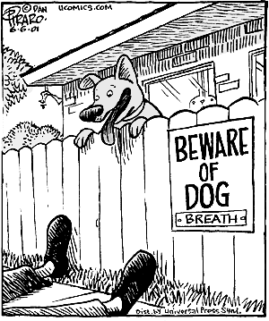
Joke of the day:
A young lady was visiting her friend who had two new dogs. The lady asked what the dogs’ names were. The friend replied, “This one is Rolex and the other one is Timex.” The lady said, “What strange names! Why did you give them those names?” “Helloooooooooooooooo,” answered her friend. “They’re watch dogs!”

Nuvallo Driving School

- Learn to drive any and all kinds of vehicles (including the Model T in the photo)!
- Offensive driving at its best!
- Make the other guy fear you—no more being afraid!
- “How to cheat insurance companies” and more sound financial advice!
- Call today, tonight, absolutely any time day or night is OK!
1—800—5727—4626
TOA Times Classifieds
For Sale
Moving soon, need to sell kitchen appliances (fridge, oven, microwave, table). E-mail me at outtaheresoon@hotmail.com
---------------------------------------------
Millions of used books—everything from spirituality to baseball. E-mail me at toomuchpaper@yahoo.com
Help Wanted
Apprentice baker, cashier wanted at newly-opened coffee & cake shop. Expecting rapid growth in near future. Must speak French, be willing to work hard. Contact Stephane at 555-8294.
------------------------------------------------
Schoolbus drivers needed. Inquire at TOA High School office. (Please, no graduates of the Nuvallo Driving School!)
------------------------------------------------
Personal
ISO beautiful lady, kind, can cook, keeps time well, likes alligators. E-mail w/ photo to capnhook@hotmail.com
------------------------------------------------
Handsome guy, wants to meet cheerful lady. I’m into yoga, mood music, and NASCAR racing. Email mixedup@oceanbottle.com
------------------------------------------------
Short, furry guy, ISO girl for chewing bones, barking, chasing cars, wagging tail, etc. E-mail cyrusthepup@yahoo.com
------------------------------------------------
Looking for gentleman with advanced degree in psychoglaciobotany. Must be rich, generous, and interested in ragtime piano. Email w/ photo to youwantwhat@rocketmail.com
------------------------------------------------
Wanted: large, furry, breathing, watercress-loving, semi-articulate mammal with antlers. Email midasmoose@yahoo.com

