Winter, 2011

Still only 50 cents!

Number 4
The Times
of

Twigglesworth-on-Avon

Scoop! “_______________

____________________”

TOA—In the latest news twist in the mysterious disappearance of Lady Twigglesworth, the _____________ Detective Agency announced today that _________________
________________________________________________________________
________________________________________________________________
________________________________________________________________
________________________________________________________________
________________________________________________________________

Mysterious Letter Found in Lady T’s Purse

Assistant Police Chief Poirot has quietly announced that a mysterious letter was found in the purse of Lady Twigglesworth. According to Poirot, “It appears to be in a foreign language that I don’t know. However, there were many hearts drawn on the paper, and I would guess it is some sort of love letter. When it has been translated, we will hold another press conference.”

Letters to the Editor

Dear Mr. Editor,
There is a menace loose in our community! I refer to the local chefs that claim to serve healthy food, but whose food is really deadly. Please, please, PLEASE don’t eat this dangerous food from local chefs!
Sincerely,
An anonymous gastronome

Dear Mr. Editor,
When will TOA people learn to keep their pets from bothering other people? Some new tenants near my house have some poor cat that constantly cries, and from the humans’ noise I think the cat may have attacked them. Far too noisy!
Sincerely,
Ear-Plug Man

From where I sit…the Editor Speaks…
Greetings to all you good people in TOA! Even in this cold weather, remember to take good care of yourself and keep warm, both inside and out. This is a great time of year to remember those dear to you—so why not tell them now that they’re special? It won’t take but a minute to fire off a quick note or an e-mail, and think of the smile you’ll bring to someone’s day.
In local news, we’ve all been watching the ongoing search for our beloved Lady T. Even though some folks here in TOA may not have liked her well-to-do ways, she was a special member of our community. I hereby call on each and every one of your to show our neighborly spirit when you see Earl T or any of employees—good people, all of them. And all of your detectives—good luck, and keep up the good work!
=====================================================================
Sir Dorrick’s “Super-Duper Portal”
Bad day with your computer??
Owned and operated by the Worchestershire family (a saucy bunch, no doubt), this new TOA business promises both fast computer access for gamers, amazing investment opportunities for money people, and help for all your computer problems ☺
Don’t kill your computer—stop in at Sir Dorrick’s today.

Garfield by Jim Davis
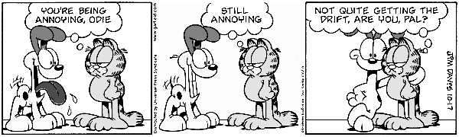
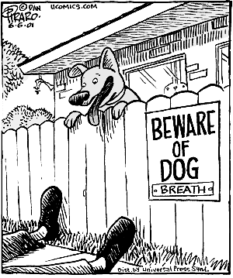
Joke of the day:
Two women that are dog owners are arguing about which dog is smarter.... First Woman: "My dog is so smart, every morning he waits for the paper boy to come around and then he takes the newspaper and brings it to me. Second Woman: "I know..." First Woman: "How?" Second Woman : "My dog told me."

Nuvallo Driving School
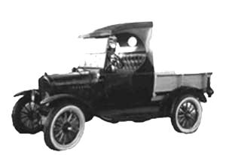
- Learn to drive any and all kinds of vehicles (including the Model T in the photo)!
- Offensive driving at its best!
- Make the other guy fear you—no more being afraid!
- “How to cheat insurance companies” and more sound financial advice!
- Call today, tonight, absolutely any time day or night is OK!
1—800—5727—4626
TOA Travel News
This week’s dream destination: Las Vegas
Shimmering from the desert haze of Nevada like a latter-day El Dorado, Las Vegas is the most dynamic, spectacular city on earth. At the start of the twentieth century, it didn't even exist; at the start of the twenty-first, it's home to well over one million people, with enough newcomers arriving to need a new school every month.

Las Vegas is not like other cities. No city in history has so explicitly valued the needs of visitors above those of its own population. All its growth has been fueled by tourism, but the tourists haven't spoiled the "real" city; there is no real city. Las Vegas doesn't have fascinating little-known neighborhoods, and it's not a place where visitors can go off the beaten track to have more authentic experiences. Instead, the whole thing is completely self-referential; the reason Las Vegas boasts the vast majority of the world's largest hotels is that around thirty-seven million tourists each year come to see the hotels themselves.


