The Times

of
Twigglesworth-on-Avon

TOA—Police reported today that a large quantity of valuable silver was stolen from the house of Earl Spencer Twigglesworth. The items included many very old kitchen utensils as well as silver platters, silver pitchers, tureens, and bowls. The value of the stolen goods was nearly $500,000 (about \42,000,000).
Earl Twigglesworth was very upset about the missing items. With Lady T having disappeared recently, he said this latest loss was a terrible thing. With no other choices, he has been eating off paper plates with plastic spoons.
Assistant Police Chief Poirot commented, “We found no sign that a thief had broken into the house—no broken windows, no doors forced open. It looks like someone knew the house very well. Of course, we are still continuing our investigation.”
===========================================================================

Twigglesworth Maid—Where?
TOA—Sherry Smith, maid for the Twigglesworth family, has been missing for several days. An avid shopper, Ms. Smith was last seen shopping over the weekend in TOA. Anyone with information about Ms. Smith is asked to contact the TOA Police as soon as possible.
Ms. Sherry Smith
Better Internet!
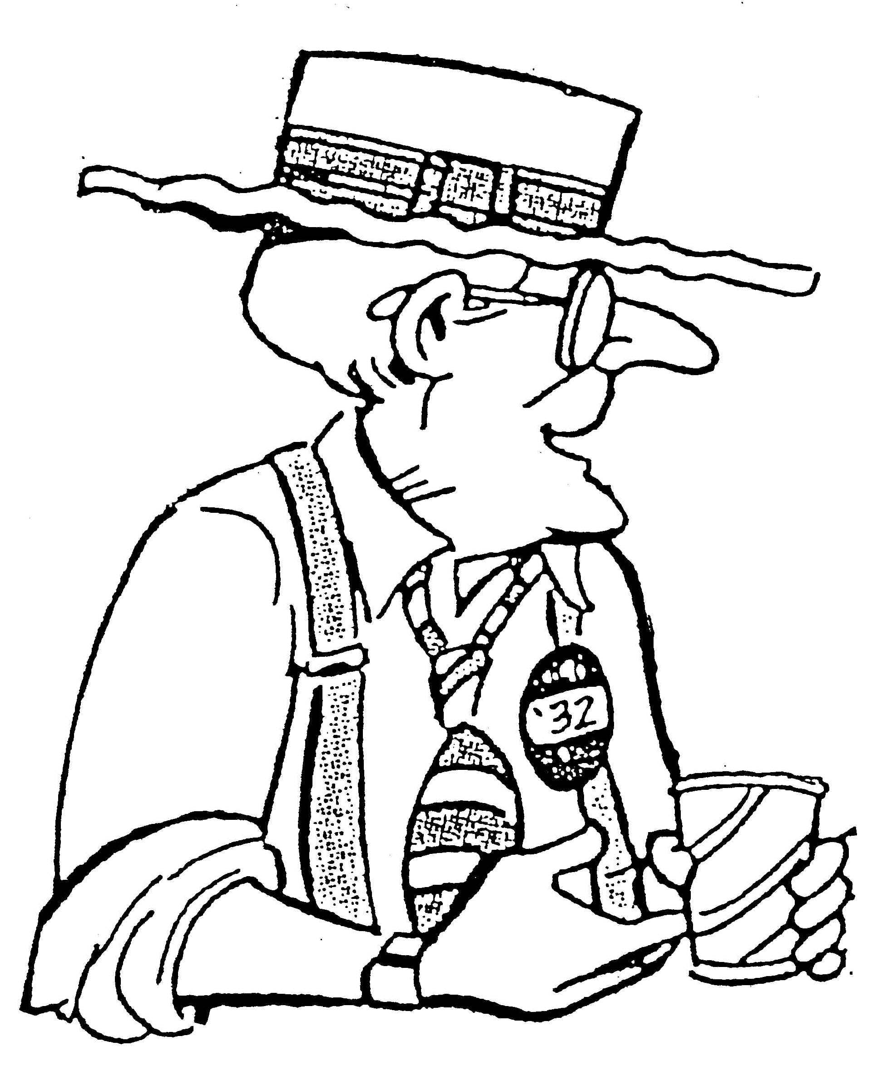
TOA—In early November Senator Burton K. Twigglesworth (cousin of Earl T) visited TOA and met with local telephone company officials to discuss local Internet access. While larger cities have speedy access, TOA with its older telephone system does not have fast Internet access. Over the next few years, however, TOA telephone lines will certainly improve and become capable of handling faster Internet connections.
Local investors in TOA Telephone stand to receive a handsome profit from the upgrade. The majority shareholder in TOA Telephone is the Twigglesworth family, and they stand to receive a large profit as the upgraded system attracts new customers.

O’Mason on vacation; stonewalls press
TOA—Police Chief O’Mason announced on Monday that he will be vacationing near the Mediterranean Sea for the foreseeable future. During his absence Assistant Police Chief Poirot will become acting chief and continue the Lady T investigation. O’Mason refused to answer questions about his sudden departure.
Today’s Weather
➔Sunny with a gentle breeze
➔Cooler and darker at night
➔Great day for flying kites
➔Visit us on the web at TOAWeather@TOA.com
Cars-A-Go-Go
- All car problems fixed—guaranteed!
- Painless prices—really and truly!
- Foreign cars? Domestic cars? We do ‘em all!
- Clean hands? Of course not—we’re busy fixing YOUR car!
- Call today, tonight, absolutely any time day or night is OK!
1-800-2273-4937

Q: Where do vampires keep their money? (answer on page 4)
Good Luck Chugs into Town for TOA Museum
TOA—In a coup for the local museum, Sir Dorrick of Worchestershire, a saucy former resident of TOA, has donated his model railroad to the TOA Museum of History. Sir Dorrick was a longtime railroad employee and train fan, and his model railroad is the result of many years of work.
Sir Dorrick’s wife, the lovely Lady Daniela, reportedly wanted the railroad out of their garage so she could park her Mercedes Benz there. The railroad covers an area of 30 meters by 40 meters, has nearly 1 km of track, and includes 3 towns and one large city. The controller stands on a raised platform with a huge control board and three TV monitors to check on all the trains buzzing about.
The TOA Museum of History, still in shock about the disappearance of their president (Lady Twigglesworth), happily accepted the donation and is looking forward to many visitors dropping by to enjoy the new exhibit.
Christmas shopping to do?
Don’t be—shop early at Sherry’s Costume Heaven!


(Garfield by Jim Davis)
Turkey Day Horoscope
- Aries (March 21-April 19). There’s no time to waste for an Arian, they want to get the show on the road and get things organized. Before you know it, they are off to get the Turkey. Stand by because everyone will have a job to do, it will be a delegated affair.
- Taurus (April 20-May 20). If there’s a Taurean in the house, don’t even think about entering the kitchen without permission. They’re in control and you can expect nothing short of a gourmet delight, with stuffing and all the other goodies
- Gemini (May 21-June 21). The twins like to be prepared, so don’t be surprised when they come home with two turkeys. You just never know when someone will drop by, so the more turkey you have on hand the better. After all, then there’s turkey for the whole week!
- Cancer (June 22-July 22). Does everyone have enough, there’s more turkey? Cancerians are great homemakers. They never forget anything, as well as making sure you have a second helping. If you are going to a Cancerian household you better not eat for a week, at least!
- Leo (July 23-Aug. 22). In the Leo household, everything is big and grand. You’ll have the biggest, latest and greatest award winning turkey Mr. or Mrs. Leo can find, even if it’s imported. There’s lashings of gravy and everything else that adorns a thanksgiving table.
- Virgo (Aug. 23-Sept. 22). Virgos are into quality control. Never mind what it looks like, or the size, or where it came from, let’s get to the most important matter of a turkey - is it juicy and flavorsome? When a Virgos in control, don’t mess with them, stand back and let them take over.
- Libra (Sept. 23-Oct. 23). The turkey has to look beautiful for a Libran to find it appetizing and more-ish. Yes, it might be the best turkey ever and cooked to perfection, but if it’s not displayed like a piece of art on the table it can lose its appeal. Don’t forget to buy the garnish!
- Scorpio (Oct. 24-Nov. 21). A Scorpio may not have been involved in the buying or cooking of the turkey, but you can be sure that they will be on call to do the official taste test. There’s no doubt that a Scorpio knows best, so don’t mess with them when turkey is involved.
- Sagittarius (Nov. 22-Dec. 21). Whatever process the turkey goes through before it gets to the table, shopping cart, basted, baked, tasted and sliced, before any morsel of turkey touches anyone’s mouth, it will need to be blessed – Sagittarians are in charge of imparting the prayers!
- Capricorn (Dec. 22-Jan. 19). When it comes to turkey for Thanksgiving Day, money is not an issue. Whatever it costs, a Capricorn will part with their hard earned dollars. Capricorns are family oriented people and money is no object when it comes to a special day like this
- Aquarius (Jan. 20-Feb. 18). Being a humanitarian, the Aquarian may be more concerned about how the turkey is treated, rather than the cooking process or how it tastes. If you’re in control of buying the turkey for an Aquarian, make sure you know the process of how it got to the market.
- Pisces (Feb. 19-March 20). If anyone appreciates a good thanksgiving dinner, it’s a Piscean. You can expect to hear positive hmm, hmm sounds that let you know all is well. It doesn’t really matter how the turkey got to the table as long as it does arrive and is extremely tasty!

A: In a blood bank, of course!
Happy Halloween!

