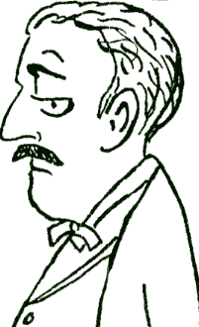
the butler →
Henry James is a traditional English butler. He has worked for the Twigglesworth family for many, many years, and they trust him very much. He is a master at clothing, and there isn’t a better butler to serve drinks and take care of guests. When he isn't working he enjoys collecting stamps and cooking (although the cook doesn’t like to share the kitchen).
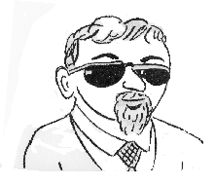
← the driver
Neither of the Twigglesworths can drive, so they employ a driver, Mike Nuvallo. He is a cousin of a famous racecar driver, and he loves the family cars, polishing and waxing them nearly every day. Sometimes he is rather short-tempered, but really he is very kind and gentle. His hobbies include Japanese flower arranging and ballet dancing.

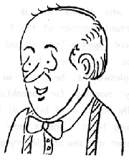
the gardener →
The Twigglesworths live in a huge, old mansion with spacious gardens, so naturally they have a gardener. His name is Chauncey, and he lovingly takes care of the many trees, shrubs, gardens, flowers, etc. His pride and joy is the family rose garden. Much of his work is done organically, as he worries about the environment. In his spare time he is a champion boxer.
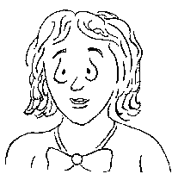
the maid →
Sherry Smith is the maid in the Twigglesworth house, and she keeps the mansion spotless. She cleans very carefully, repairs any broken things, and often has good ideas for improvements. She’s always a happy, smiling lady, and she enjoys knitting and watching American football on TV, and she and Twinkletoes (the cat) are wonderful friends.

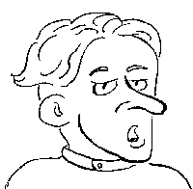
← the cook
Of course, in the Twigglesworth mansion there is a full-time cook. Stephane Lemond is French and a wonderful cook, especially of cakes and pastries. He is very, very particular about his kitchen, and he doesn’t like to share it with anyone! Earl T also speaks French, so they often enjoy chatting in French. In his spare time Stephane likes playing soccer and reading, mainly mystery and action novels.

