The Emperor’s New Clothes
(From Andersen’s Fairy Tales)
by Hans Christian Andersen
Many years ago, there was an emperor, who was so excessively fond of new clothes, that he spent all his money on clothing. He did not trouble himself in the least about his soldiers, nor did he care to go either to watch a play at the theatre or to go hunting—except when he could display show off his new clothes. He had a different suit for each hour of the day, and while with any other king or emperor, people could say, “He is sitting in a meeting,” with the emperor it was always said, “He is sitting in his clothing room.”
Time passed merrily in the large town which was his capital; strangers arrived every day at the emperor’s court. One day, two rogues, calling themselves weavers, made their appearance. Soon it became known that they could weave fabric of the most beautiful colors and elaborate patterns. It was so breath-taking that the clothing made from it would remain invisible to everyone who was unfit for the office he held, or who was extraordinarily simple in character.
“These must, indeed, be splendid clothes!” thought the Emperor. “If I had such a suit, I might at once find out what men in my country are unfit for their office, and also be able to distinguish the wise from the foolish! This cloth must be woven for me immediately.” He then caused large sums of money to be given to both the weavers in order that they might begin their work at once.
Thus the two pretend weavers set up two looms, and pretended to work very busily, although in reality they did nothing at all. They asked for the most delicate silk and the purest gold thread, put both into their own knapsacks, and then continued their pretended work at the empty looms until late at night.
“I would like to know how the weavers are getting on with my cloth,” said the Emperor to himself, after some little time had elapsed; he was, however, rather embarrassed, when he remembered that a simpleton, or one unfit for his office, would be unable to see the cloth. To be sure, he thought he didn’t need to worry about himself (being able to see the cloth), but yet, he would prefer sending somebody else, to bring him intelligence about the weavers, and their work, before he troubled himself in the affair. All the people throughout the city had heard of the wonderful property the cloth was to possess; and all were anxious to learn how wise, or how ignorant, their neighbors might prove to be.
“I will send my faithful old minister to the weavers,” said the Emperor at last, after some deliberation. “He will be best able to see how the cloth looks, for he is a man of great common sense, and no one can be more suitable for his office than he is.”
What will happen next?
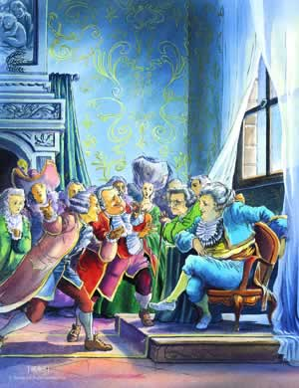
Our story so far: Two strangers with a very unusual talent have come to the emperor’s city and begun making something. Only two kinds of people can see what they make, and the emperor sends his faithful old minister to check on their progress.

The Emperor’s New Clothes, Part 2
So the faithful old minister went into the hall, where two rogues were working with all their might, at their empty looms. “What can be the meaning of this?” thought the old man, opening his eyes very wide. “I cannot discover the least bit of thread on the looms.” However, he did not express his thoughts aloud.
The impostors very courteously requested him to come closer to their looms, and then asked him, while pointing to the empty frames, whether the design pleased him, and whether the colors were not very beautiful. The poor old minister looked and looked, he could not discover anything on the looms, for a very good reason: there was nothing there. “What!” thought he again. “Is it possible that I am a simpleton? I have never thought so myself, and no one must know it now if I am so. Can it be that I am unfit for my office? No, that must not be said either. I will never confess that I could not see the stuff.”
“Well, Sir Minister!” said one of the imposters, still pretending to work. “You have not said whether the cloth pleases you.”
“Oh, it is excellent!” replied the old minister, looking at the loom through his spectacles. “This pattern, and the colors, yes, I will tell the Emperor without delay, how very beautiful I think them.”
“We shall be much obliged to you,” said the fake weavers, and then they named the different colors and described the pattern of the imaginary cloth. The old minister listened carefully to their words, in order that he might repeat them to the Emperor; and then the two weavers asked for more silk and gold, saying that it was necessary to complete what they had begun. They had (they said) used all that had been given them (but it was really in their knapsacks), and they continued to work very diligently at their empty looms.
The Emperor now sent another officer of his court to see how the men were getting on, and to ascertain whether the cloth would soon be ready. It was just the same with this gentleman as with the minister; he surveyed the looms on all sides, but could see nothing at all but the empty frames.
“Does not the cloth appear as beautiful to you, as it did to my lord the minister?” asked the impostors, at the same time making the same gestures as before, and talking of the design and colors which were not there.
“I certainly am not stupid!” thought the messenger. “It must be, that I am not fit for my good, profitable office! That is very odd; however, no one shall know anything about it.” Thus did he praise the cloth he could not see, and declared that he was delighted with both colors and patterns. “Indeed, your Imperial Majesty,” said he to his sovereign when he returned, “the cloth which the weavers are preparing is extraordinarily magnificent.”
The whole city was talking of the splendid cloth which the Emperor had ordered to be woven at his own expense.
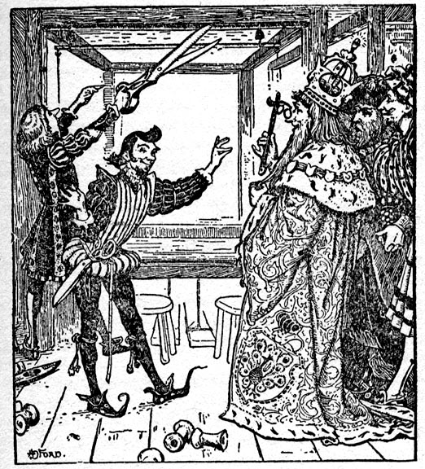
And now the Emperor himself wished to see the costly manufacture, while it was still in the loom. Accompanied by a select number of officers of the court, among whom were the two honest men who had already admired the cloth, he went to the crafty impostors, who, as soon as they were aware of the Emperor's approach, went on working more diligently than ever; although they still did not pass a single thread through the looms.
“Is not the work absolutely magnificent?” said the two officers of the crown, already mentioned. “If your Majesty will only be pleased to look at it! What a splendid design! What glorious colors!” and at the same time they pointed to the empty frames; for they imagined that everyone else could see this exquisite piece of workmanship.

