Name ________________________

Our next story is from “A River Runs Throught It,” which is based in my home state of Montana…
- Where is Montana? (on the map, draw Montana and the Rocky Mountains)
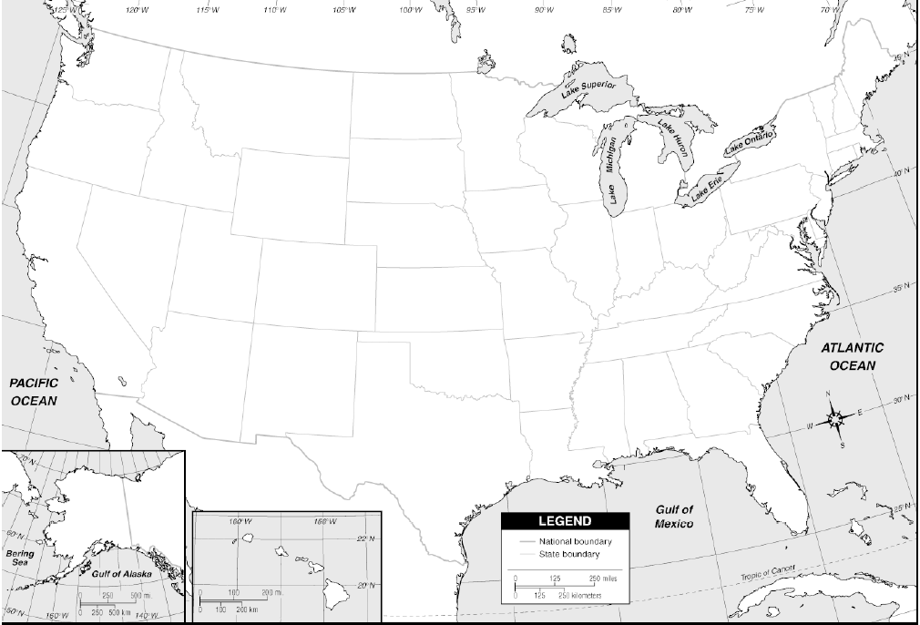
- Who was Norman Maclean?
- What country did his family come from? (hint: perhaps his family name has a clue?)
- The Presbyterian Church plays an important part in this story. Find some information on that church (what kind, where, how big, etc.).
- This story is set in the early 20th century. What historical events happened in the 1910s and 1920s?
- Next visit this webpage:
http://www.library.csi.cuny.edu/dept/history/lavender/riverruns.html
Who are some other writers of “New Western Literature”?

