Good morning, everyone! Today we’ll be going on a small world tour ☺

Step 1. Locate these countries: Holland, Brazil, the US, Thailand, Cameroon, France, New Zealand, Egypt, China, Libya, and Sri Lanka. Next, select and locate one more country.

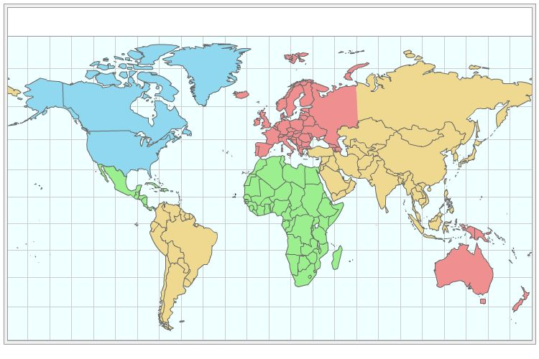

Step 2. For each country, jot down a couple things that you know.
Step 3. Choose one country and imagine that you are a young person from that country. What dream or dreams might you have? Why?
Step 4. Imagine that you are the leader of that country (e.g., the president or prime minister). What difficulties might you face?

