Seven plots tell the whole story—or is it eleven?
Dalya Alberge, Arts Correspondent
More than 200 years ago, Samuel Johnson surmised that fiction was limited to a few plots “with very little variation.” Now a major study has worked out that there have been just seven since storytelling began.
The Seven Basic Plots: Why We Tell Stories explores every form of fiction—myths and folk tales, classic plays and novels, films and TV soaps. Christopher Booker, its author, found the same archetypal themes everywhere, from Beowulf to The Lord of the Rings. “In fact, there is no kind of story, however serious or trivial, which does not spring from the same source and is not shaped by the same archetypal rules,” he said.
His findings initiated debate among authors and scholars, with Philip Pullman, whose The Amber Spyglass won the 2002 Whitbread prize, suggesting there may be 11 plots. Booker, a founding editor of the satirical magazine Private Eye, whose books include the Great Deception, an academic history of the European Union, was writing another book when he found his attention drawn to Shakespeare’s Macbeth, Nabokov’s Lolita, and Truffaut’s 1960 film Jules et Jim. “These stories might not seem to have much in common,” he said. “But what haunted me was the way that, at a deeper level, they all seemed to unfold around the same general pattern.”
This basic pattern was tragedy, culminating in the destruction or death; it is balanced by comedy, not just a general term, but an identifiable form of plot, which follows its own terms.
Booker set out to widen his search, listing stories such as David and Goliath, Dracula and the James Bond novels, where a hero or heroine overcomes a terrifying monster; rags-to-riches tales such as Cinderella and David Copperfield; quests as in King Solomon’s Mines or Jason and the Golden Fleece; voyage and return, as in Alice in Wonderland or The Time Machine; and rebirth, in which a trapped victim is brought to the light, as in the The Sound of Music or Sleeping Beauty.
“Before long I began to make a startling discovery. Not only did it seem that there were a number of basic themes or plots which continually recurred in the storytelling of mankind, shaping tales of very different types and from almost every age and culture; even more surprising was the degree of detail to which these basic plots seemed to shape the stories they had inspired.”
Pullman has long been interested in the subject. His 11 basic plots include a “beauty and the beast” category, where the monster is transformed by the love of the pure and innocent (Jane Eyre), a Shane plot, named after the novel and film, in which a stranger arrives, settles a problem and rides on; and “the ugly duckling,” where the overlooked, downtrodden girl or boy is transformed into a winner (The Tortoise and the Hare, David and Goliath).
Dame Beryl Bainbridge, whose novels include According to Queeney, a story of Dr. Johnson’s relationship with his benefactor and her daughter, said, “I’m fully in accordance with the book. It’s what you do with the seven plots and how you alter them around that matters.

The Magic 7

Voyage and Return: Alice falling into an abnormal and disorientating Wonderland but ending up back home. Other examples are The Wizard of Oz, The Ancient Mariner, and H. G. Well’s The Time Machine.

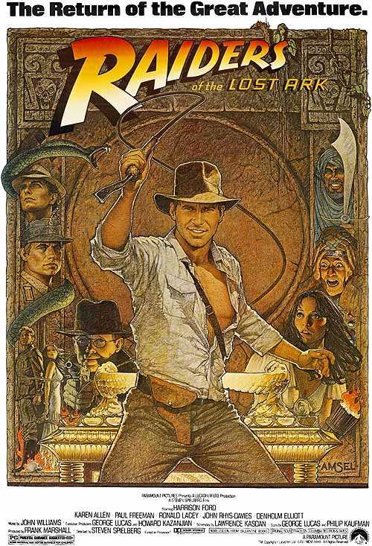
A Quest: Perilous journey to reach a priceless goals, such Jason and the Golden Fleece and Raiders of the Lost Ark.

Rags to Riches: Ali Examples include Cinderella, Jane Eyre, David Copperfield, and My Fair Lady.

Comedy: Not a genreal term, but an identifiable form of plot following its own rules. Examples include Mr. Bean, Monty Python, Fawlty Towers, and

Tragedy: Archetypal plot culminating in destruction and death. Examples include King Lear and Faust.

Overcoming the Monster: Many of these stories, from Jaws to Gozilla, Jack and the Beanstalk, and the James Bond Series. Harry Potter would likely fall into this category, too.

Rebirth: In which a character is trapped then redeemdd and brought into the light. Examples include The Sound of Music, Sleeping Beauty, and Dickens’ A Christmas Carol (below, with Mickey).

