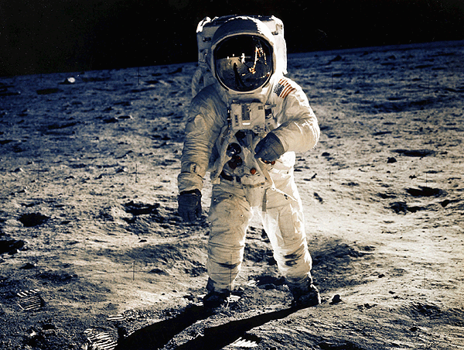
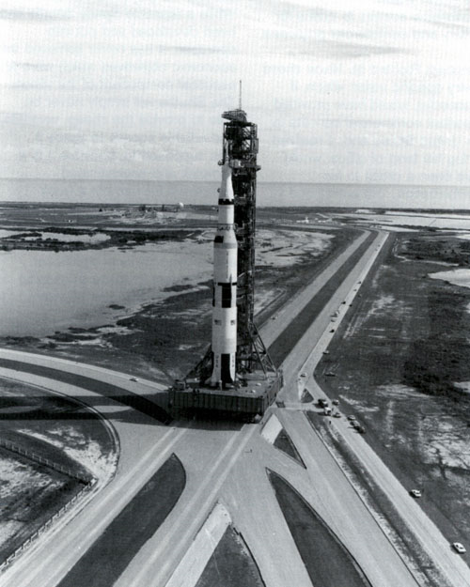
When I was a little boy, the Apollo space program was in its heyday, and like many little boys, I was fascinated. We all drank Tang like the astronauts did, tried the awful freeze-dried food like the astronauts ate, and dreamed of going into space to explore new worlds and travel where humans had never ventured. If you remember the Star Trek series and movies, the motto was “To boldly go where no man has gone before.”


1. What inspired you when you were young?

2. What inspired you to pursue medicine?

3. What is your current inspiration?

