Today, we will give you an assignment. Please solve these questions by July 4, our next class.
Today we will learn about samurai, and we will especially talk about Shinsengumi and one other group. Before you learn about them, I want you to do some preparation. Therefore, we have assigned this paper. Are you ready?

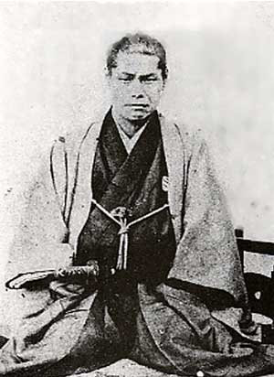
1. Who he is? Where he was born? ➔

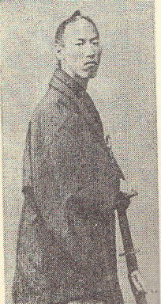
⬅ 2. Who he is? What two or three things was he famous for ?

3. Of the two men on this paper, which man was the first leader?

4. After Shinsengumi went to Kyoto, where did they first establish their base?

5. What was the purpose of their move to Kyoto?

Please fill in the blanks.
After September of 1863, who held the following posts?
Leader: ____________________
Sub Leader: ____________________
President: Keisuke Yamanami
Staff: ____________________ and Kanryusai Takeda

Head of the group
No. 1 Souji Okita No. 6 Genzaburo Inoue
No. 2 ____________ No. 7 ____________
No. 3 ____________ No. 8 ____________
No. 4 Chuji Matsubara No. 9 Sanjuzaburo Suzuki
No. 5 Kanryusai Takeda No. 10 ____________

Some questions
1. Who was the man who suggested making the Roshigumi?
2. What happened in September, 1863?
3. What was the maximum number of people in Shinsengumi? About ______ people
4. The group name changed from Roshigumi to _______________.
5. What happened in June, 1864?
6. What was the law in Shinsengumi and what was the content?
Law name ____________________
Content (in Japanese) ____________________________________
______________________________________________________
7. What was Kondo’s sword style (流派)?
8. Who were the five most beautiful (cool) men in Shinsengumi?
9. Why did Okita die?
10. Where were their costumes made? ➔

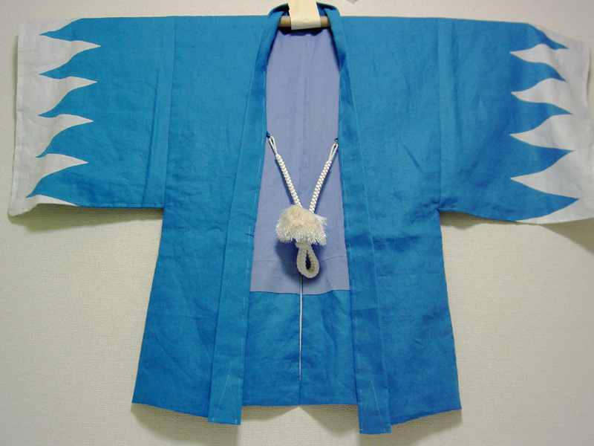

Where are the following locations?

No.1
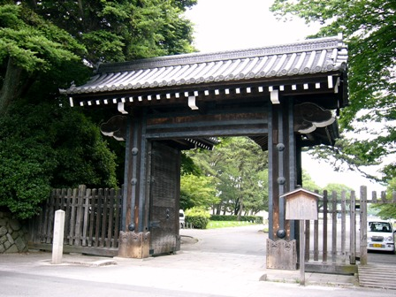

No. 2

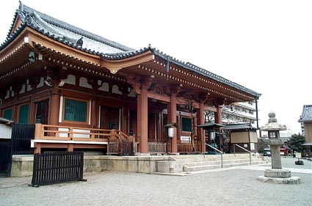

No. 3
