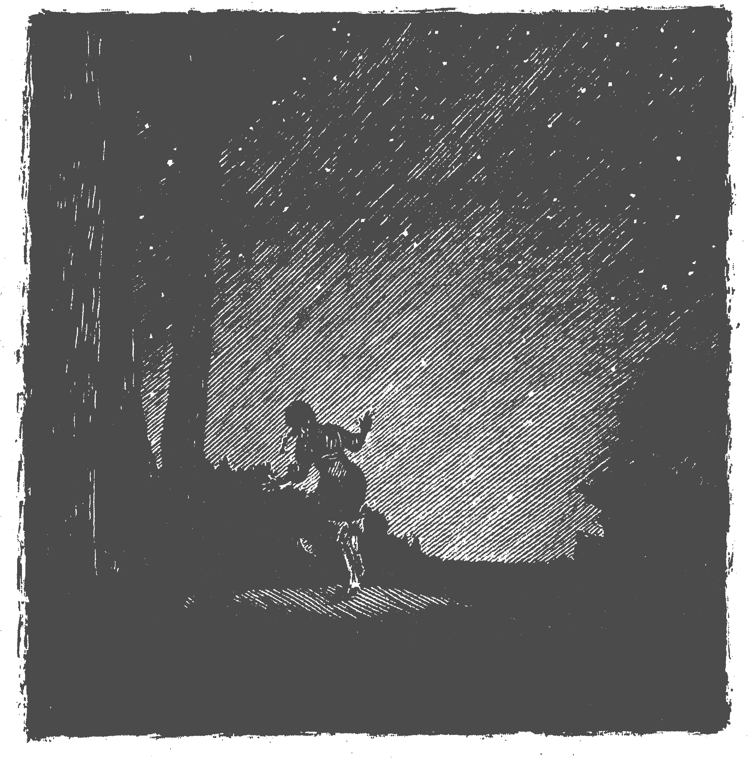
0rphan Journey Home
Chapter 2:
Where is Moses Going?
The story so far: Jesse Damron’s family is moving back to Kentucky, but her older brother Moses doesn’t want to leave.

May 4, 1828
West bank of the Little Wabash River, Illinois.

I wake suddenly in the night, hearing voices outside. I sit up slow, trying not to wake Louisa. I look out the tiny square window above our bed, and I see Moses talking with Papa. The moon is coming in and out of the clouds, so sometimes I can see their faces and sometimes I can’t. Moses says, “Papa, since you sold all the animals, how can you work or get food?”
“I’ll go back to working with stone. Every town needs a mason. Or I’ll open a flourmill.”
Moses answers, “I know you don’t like this land near the river, but there’s better farming on high ground.”
“Moses, I’m not a farmer,” Papa says. “I’m no good at growing corn, and you know that your mama misses her family. Come on to bed. We need to get up early in the morning.”
Moses turns away and says, “I talked to a man in town. He told me the western prairie is bigger than the sea. Maybe I’ll try my luck there.” He waves his hand toward the west, as if he can see the open prairie from here.
“That’s fine, but it’s dangerous. You’re likely to get bound out, traveling alone.”
Bound out. Mama has told us stories about orphan children who get bound out. She says people treat bound out children like slaves, and they can’t get away until they’re grown.
“I'm almost fourteen,” Moses is saying, standing up tall.
Papa laughs gently. “You’ve grown tall, son, but you’re still young and it’s dangerous. And how do you think I feel? I don’t want to go back to a slave state. I’m a Freemason—we believe in equality. But we’ve decided to go back to Kentucky.”
“Moses, if you want to go west, you may,” Papa says quietly. “But you should explain it to your mama yourself.”

Later I wake again. Below, moonlight shines through the window into the kitchen. As I’m looking, suddenly I see Moses. He picks up a sack, then reaches up over the door where Grandfather’s Kentucky rifle hangs.
Moses goes out the door, and I pull on my clothes quietly. I have to stop him—we need that rifle, and we need Moses, too!
Outside I run past the corral where our animals are. Nearby the sound of the river whispers in the darkness. Moses must be going to the town, so I run into the forest toward town. As I’m running, I hear an animal calling—maybe an owl? A deer? A wolf? Sometimes there are dangerous animals in those woods.
In just a couple minutes I come to a clearing in the forest, and there I see my brother. He’s sitting on a log, but he jumps up as I run into the clearing.
“Jesse! What are you doing here?”
I glare at him and say, “Moses, I’m chasing you! You can’t leave, and you can’t take the rifle, either.”
Just then, we hear a shout in the distance. “That’s Papa! Why’s he shouting?”
We both start running back toward our cabin, and we hear Papa shout again. Why in the world is he shouting in the middle of the night?
Next time: A Visitor

Story by Liz Ketchum
Illustration by C.B. Mordan
Reprinted with permission from Breakfast Serials

