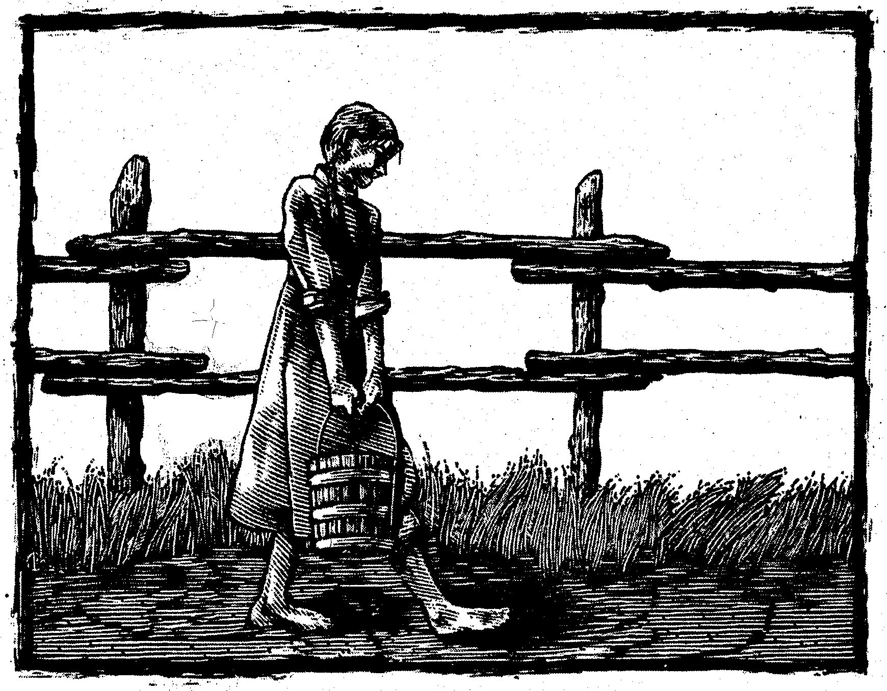
0rphan Journey Home
Chapter 1:
Papa’s News
This story, set in 1828, follows the story of the Damron family as they journey back to their home in Kentucky. Although fictionalized, this is based on true events.

May 1, 1828
West bank of the Little Wabash River, Illinois.

“Jesse! Moses!” Mama calls from the cabin. “Finish your chores and come quick. Papa has a surprise.”
Mama sounds excited. I look up from milking Nettie. “Moses, did you hear?”
“I’m not deaf.” Some hay falls down from the loft and lands near Nettie’s feed box. The cow’s tail flicks against my face.
“Whoa, Nettie.” I push my arm against her leg to keep her still. What could the surprise be?
“Wonder what Papa wants to tell us?” I ask.
Moses scowls at me and says, “Nothing good.”
I sigh. Moses and Papa have both been acting strange lately. Yesterday morning, Papa left the plow sitting in a field, went off in the wagon, and didn’t come home until after dinner. And Moses keeps riding away on Ginger, his horse. He carries Papa’s gun but he comes back with nothing, and he won’t tell me where he’s been.
I lug the heavy bucket to the cabin, careful not to spill milk on my skirt. What is Papa's surprise? Did he sell Nettie's calf in Shawneetown? Maybe he bought us some pretty cloth or some shoes—oh, that would be wonderful!
When I go inside, there are no packages on the table. The pale boards are scrubbed clean. Mama sits at one end, with Louisa on her knee. Solomon is on his chair. Papa’s beard is wet and his hair is brushed back as if it were Sunday.
This is strange—why is everyone so quiet? I glance around the cabin to see if I’ve missed something, but it seems the same. Soup is cooking in the big iron kettle over the fire. Mama’s herbs are dusty, hanging from the rafters, and sunshine in the doorway makes the rest of the room seem gloomy.
“Set the milk down, Jesse,” Papa says. “Moses, come sit with the family.”
My older brother shakes his head. He’s leaning against the wall, his arms folded over his chest. His eyes are as dark as Papa’s, but they don’t have Papa’s warm shine. “I know what you’re going to say.”
Papa ignores Moses and turns to me. “Jesse,” he says, “I have good news. Can you guess?”
I look around. “You bought me some shoes? Maybe a dress?”
Papa sighs. “No, Jesse, I’m sorry, but maybe this is better. It’s something you’ve wanted for a long time."
What could I want more than shoes? I glance at Solomon. His big brown eyes look puzzled. Louisa holds her doll, but she doesn’t know either. Then I look at Mama’s wide smile, and my heart jumps. “We’re going home?” I whisper.
Papa nods. “Home to Kentucky? And Grandma?” I jump up, so happy I could dance. “Oh, I’m so happy!”
“Jesse! Jesse! Calm yourself.” Mama tries to scold me but she hugs me back.
“When?” I ask.
“As soon as the roads are dry,” Papa says.
“But Papa, you promised!” Moses says. His dark eyes plead with Papa. “You said if the Damron family moved again, we’d go west, where the prairie goes on forever.”
We hold our breath, waiting for Papa’s reply, but he shakes his head and looks down at his hands.
“Then you’ll have to travel without me,” Moses says. The door closes, and my brother is gone.
Next time: Where is Moses Going?

Story by Liz Ketchum
Illustration by C.B. Mordan
Reprinted with permission from Breakfast Serials

