Vuvuzelas Stir Online Debate at World Cup

AFP - You either love them or you hate them and the vuvuzela is stirring up some impassioned debate on Facebook, YouTube, and other sites online.

The one-meter long plastic trumpet is as essential an item to South African fans as getting decked out in the national colors or painting one’s face and they have been out in force in the opening days of the tournament.
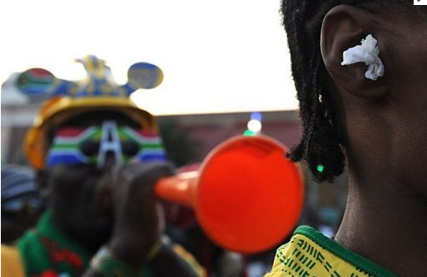
Eighty thousand of them being blown at full volume sounds like a swarm of angry bees buzzing in your ear, or, as one newspaper put it, an elephant in distress. It is a tuneless din that takes getting used to, and they are not just being blown at stadiums, but in hotel lobbies, in shopping malls, and on the streets.

“It’s our way to motivate players, to express happiness and how do you feel in the stadium,” said 23-year-old Sazi Mhlwatika as he shopped in Johannesburg. “We are used to them and you can’t enjoy the game without vuvuzelas. If there were no vuvuzelas, there would be no game. It’s just a traditional thing in South Africa. Abroad, they sing from the first minute to the end, here we blow vuvuzelas from the beginning to the end.”

But not everyone is embracing them with shops in Cape Town running out of “vuvu-stopper” earplugs. “I could have sold 300 pairs of earplugs yesterday if I’d had the stock, and the same today, but I’ve only got 200 pairs and that’s just about finished,” one local shopkeeper said. “We can’t keep up,” added the owner, who has ordered 1,000 more.

Another said they ran out last week. “We’re already deaf,” she said.

The earplugs, marketed as the “Vuvu-Stop”, have a label on the back of the packet which reads: “Highly effective noise reduction. Uses include soccer, rugby, or for couch potatoes to block out your wife’s moaning.” They claim to have a noise-reduction rating of 31 decibels.

This helps given Switzerland’s Hear the World Foundation—an initiative to raise awareness about hearing loss—said tests showed that, at full volume and pressed against your ear, a vuvuzela (127 decibels) is louder than a chainsaw (100 decibels).

Studies have also shown they contribute to the spread of cold and flu germs.

It appears the trumpets have also hurt the sensibilities of some foreign players, who have lobbied for it to be outlawed, claiming it affects their concentration. The drone has also attracted plenty of disparaging comments online. One You Tube video providing an insight into the instrument has been viewed by 250,000 people, and it seems many don’t like it.

“What an absolutely disgraceful, ear-wrenching noise,” wrote one person.

Another said: “The tv stations need to create some sort of noise filter.”

On Facebook, numerous pages have sprung up calling for a vuvuzela-free World Cup. There is even a website dedicated to getting rid of the horn: www.banvuvuzela.com. It is running a poll, asking people to vote for or against the trumpet at the World Cup. As of Sunday, nearly 30,000 wanted it banned while only 6,500 wanted it to stay.

However, FIFA president Sepp Blatter has given them his blessing, blasting the detractors by telling them Africa is about dance and music and moaning about the instrument bordered on discrimination. Moreover, there is little sympathy for sufferers from World Cup organizers, who insist that the vuvuzelas are a potent symbol of the tournament, the first time the World Cup has been held on African soil. “Everybody loves vuvuzelas,” said Rich Mkhondo, spokesman for the local organizing committee. “They are the symbol of the tournament.”

Vuvuzelas are said to be based on kudu horn instruments and rooted in African history, blown to call villagers to meetings.The plastic version started to be mass-produced in 2001.

Retrieved June 18, 2010, from http://www.france24.com/en/ 20100613-vuvuzelas-stir-online-debate-world-cup

