- Punctuation, Lesson 2
  - A period is a strong stop.
I love strawberries. However, I don’t like cranberries. ⬅ STRONG
  - A semi-colon is similar to a period, but weaker.
I love strawberries; however, I don’t like cranberries. ⬅ medium
  - A colon is used for lists or to explain more
I like many kinds of fruit: apples, oranges, pears, and peaches.
  - Parentheses are like a blanket (wrap around the “inside”)
  - Note the spacing in (c)…no space inside (the red arrows) and one space outside (the green arrow)
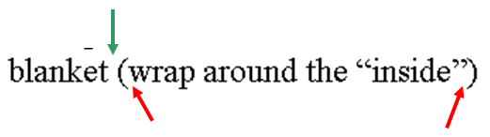
For example…
(ex1) like a blanket (wrap around the “inside”) ⬅ OK!
(ex2) like a blanket(wrap around the “inside”)
(ex3) like a blanket( wrap around the “inside”)
(ex4) like a blanket (wrap around the “inside” )

Only (ex1) is OK!

  - Period, comma, semi-colon, and colon: no space before, one space after

He called and said that his plane would arrive late.
Of course, there may be dissenting opinions, too.
I love strawberries; however, I don’t like cranberries.
I like many kinds of fruit: apples, oranges, pears, and peaches.
Mr. Elwood
Dear Mr. Elwood,

Exception: for time, there is no space after a colon… 6:45

