
- What is the little girl’s name?

____
15
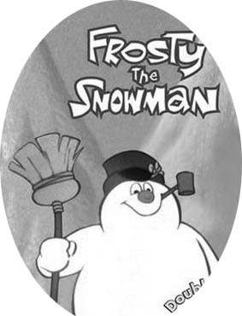
- What is the rabbit’s name?
- What is the magician’s name?
- How does Frosty come to life the first time?

- Frosty has a problem—what is it?

- Where do they decide to take Frosty?

- How much does a ticket cost?

- How do they travel?

- The animals build a fire—why?

- What happened in the greenhouse?

- Why did the magician promise not to bother Frosty anymore?

- Where does Frosty finally go?

Vocabulary… again, write an English definition.
- snowman =
- magician =
- rescue =

