Printing Posters for the Poster Presentations
Several copy cards will be available (3-4 for the part-time teachers and one each for the three full-time teachers) specifically for this purpose. Students can borrow these cards from their teacher and print multiple pages using the copy machine on the 6th floor; this copy machine can print either color or black-and-white. Using this copy machine, however, means that students will have to print multiple A3- or A4-size papers for their A0-size poster (see the paper sizes on page 2).

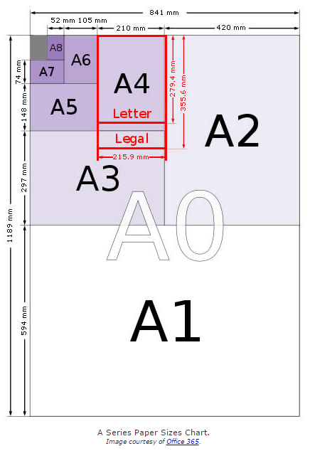
A4 paper = 21.0cm x 29.7cm
A3 paper = 29.7cm x 42.0 cm
A0 paper = 84.1cm x 118.9cm

Thus, A0 equals 8 A3 papers.

Of course, student posters could be portrait or landscape; most posters I have encountered are landscape.

