Possible openings
for the introduction of a presentation

- General statement
- Background information
- History
- Anecdote
- Number and/or fact
- Definition
- Quotation by a famous person
- Question

Today I will talk about rare earth metals. interesting???

Topic: Rare earth metals
Anecdote = story, often a personal story
- Anecdote about all the devices that use rare earth metals
- Number or fact: In Japan, what percentage of people have cell phones?
106.8 million users
106.8 / 127 = 84.1%
“84.1%. 84.1 percent of the population of Japan.”

“106.8 million.
Over 100 million.
100 million users.
Of cell phones.
Over 100 million cell phone users in Japan.

- Definition: define ‘rare earth metal’
A rare earth metal is one of 17 elements of the 116 in
the periodic table. These include such elements at yttrium,
scandium, and …, yet these elements are not truly rare. ‘Rare’
in this case refers to the difficulty of extracting them.
- Quotation by a famous person
“Man is a slow, sloppy, and brilliant thinker; computers
are fast, accurate, and stupid.” ― John Pfeiffer

According to John Pfeiffer, “Man is a slow, sloppy, and brilliant thinker; computers are fast, accurate, and stupid.” To this we might add
that computers are very, very common—in our homes, in our
schools, in our workplaces, in our cars, in our devices. In short,
computers are everywhere!
Computers, of course, must be constructed, and in every computer
and in every technological device, we use something called rare
earth metals. These are …
- Question
Do you have a cell phone? How about a computer? A hybrid
car? If you do, then you benefit from the use of rare earth
metals, which are found in all of these devices.

Avoid vague expressions.
“We should think about global warming.”
- People should first actively learn about global warming and
then take steps in their private lives to combat it.

“It can be said that …” (By whom?)
Say it!!!
“It can be said that young people can’t use kanji correctly.”
- Young people can’t use kanji …

When concluding your presentation, a common device is to
bookend something.
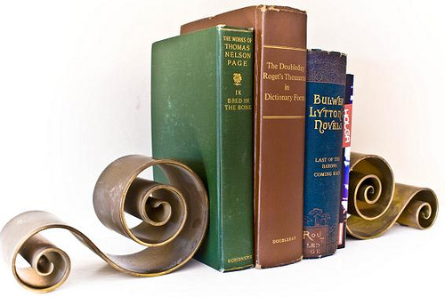

Topic: rare earth metals
Introduction: According to John Pfeiffer, “Man is a slow, sloppy, and brilliant thinker; computers are fast, accurate, and stupid.” To this we might add that computers are very, very common—in our homes, in our schools, in our workplaces, in our cars, in our devices. In short, computers are everywhere!
Computers, of course, must be constructed, and in every computer and in every technological device, we use something called rare earth metals. These are …
Body: three main points …
Conclusion: While it is likely true that man is, as John Pfeiffer
noted, a slow, sloppy, yet brilliant thinker and computers are
quite the opposite, the stupid computer has revolutionized
our world. We owe this fact, of course, to those rare earth
metals that …

Topic: rare earth metals
Introduction: 106.8 million. Over 100 million. 100 million users. Of cell
phones. Over 100 million cell phone users in Japan.
Body: three main points …
Conclusion: Again we come to that singular number. 106.8
million. Cell phones. In Japan. [repeat main points]

How long ago was I born? Say, 20 years and counting, but
let’s look at that another way. 20 years would be 7300
days old.

20,000. 20,000 days ago I was born.

