Script for Bridges Presentation
[student name]
May, 2023

Slide 1: title slide
Good morning. My name is _______, and I’m a student at Meiji University in Tokyo. … … … … … … … … … … … interesting intro here … … … … … … …

Slide 2: table of contents slide
Here are the points that I will talk about today, and we will have time for questions at the
end of my presentation.

Slide 3: Parameters:

Slide 4:

Slide 5:

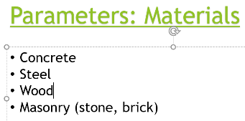
Slide 6: Materials
The first consideration is the type of materials that are necessary for the bridge. We have, of course, quite a few possibilities, including …

Slide 7:

Slide 8:

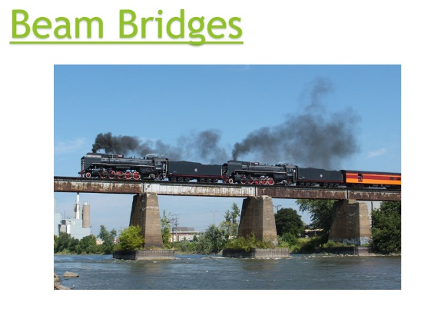
Slide 9: This picture shows a steam train crossing an old beam bridge. This is a common sight on train bridges worldwide, and this particular picture is from Ohio in the United States. As you can see, the bridge is quite simple with only pillars and the horizontal deck, which is strong enough to carry the weight of a train.

Slide 10:

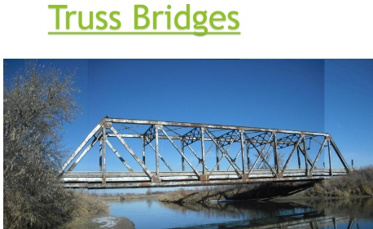
Slide 11: Truss bridge example
Here is a fine example of a truss bridge that is located in Iowa in the United States. It was originally a railroad bridge but was moved and subsequently used for car traffic across a small river. It shows the typical triangles (the trusses) of this very functional and common type of bridge.

…

Slide 12:

Slide 13: In this picture we see the red Forth Bridge located in Edinburgh, Scotland.

Slide 14: Another example of a cantilever bridge can be found crossing Tokyo Bay in Japan. The Tokyo Gate Bridge was completed in 2012 and is located near Haneda Airport.

Slide 15:

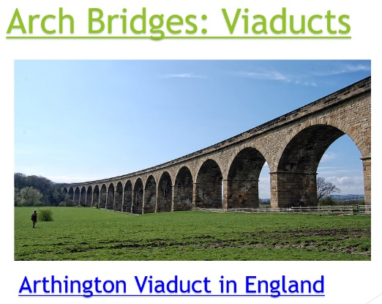
Slide 16: Arched bridges are also called viaducts, and shown in this picture is the Arthington Viaduct in England. It has a total length of 500m with a maximum height of 27m; each arch is 18m. It carries the Harrogate Line, a railroad, across the Wharfe Valley and was completed in 1849.

Slide 17:

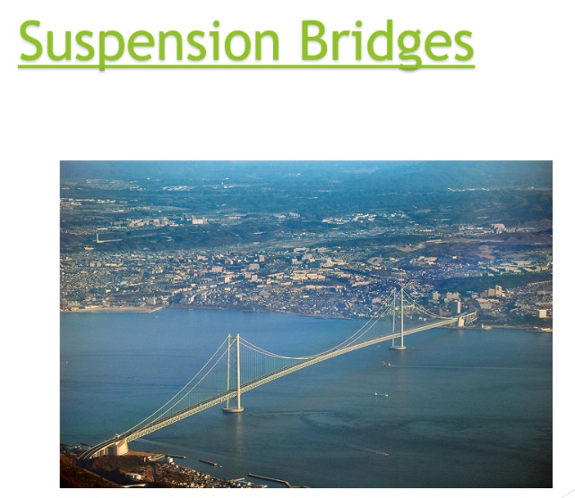
Slide 18: Connecting Kobe with Awaji Island, the Akashi Kaikyō Bridge in Japan is an example of a suspension bridge. As is apparent in the photograph, suspension bridges can be extremely long; this bridge has a central span of 1991m, which is the second longest in the world.

…

Slide 19:

Slide 20: This combination cable-stayed bridge, the Millau Viaduct, was completed in 2005 and is located in southern France. It crosses the gorge valley of the Tarn River and was built to ease traffic congestion in the area. It is the highest (tallest) bridge in the world with a height of 336.4 meters.

Slide 21:

Slide 22: Thank you for your kind attention.

