How to Lead an Effective Roundtable Discussion
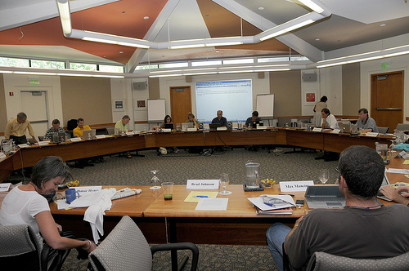
Roundtable Discussion (Photo credit: jdlasica)
What is a Roundtable Discussion?
A roundtable discussion allows extensive discussion and feedback for the presenter in a more informal way than a panel presentation or workshop. Presenters are usually referred to as “hosts” and only provide brief handouts (usually a one-page print-out of key points and possibly some questions) because the emphasis is on the discussion itself, rather than a formal presentation. The goal is to get everyone involved and participating in the discussion. In my case, I’ve been invited as a personal branding expert, but really the key is to facilitate rather than direct.
Key qualities of a roundtable discussion:
- Informal
- Emphasis on discussion
- Audience plays an active role
There are many different structures for roundtable discussions. One effective way to begin is by asking each participant, “If you could have one answer about [roundtable topic] that would help you understand it better, what would it be?” This method helps narrow the topic in a way that is most important to your audience. It helps prioritize the roundtable’s discussion.
Sample structure for a roundtable discussion:
- Introduction: who you are, why you’re here.
- Participant Introduction: name, organization, their interest/expectations for the roundtable discussion topic
- Topic Introduction: what will you be speaking about, tell the participants what you will tell them during your presentation
- Main Points: communicate the main ideas and sub-ideas
- Discussion: this will be the bulk of the time and is discussed in more detail below
- Review: tell the table what you’ve just covered, summaries main points
- Conclusion: thank participants for attending and engaging in the discussion, let them know if you will follow-up and state when the next meeting will take place
How Does One Effectively Lead a Roundtable Discussion?
Leading a roundtable discussion can be challenging. Some participants will be reluctant to speak up, while others may speak up too much or take the discussion off-track. It is important to know what effective roundtable discussions look like as well as tips for effectively managing roundtable discussions. Both are discussed below.
Qualities of an Effective Roundtable Discussion
- Time managed carefully so there is plenty of time for discussion
- Speaker communicates a clear message and solicits specific feedback
- Speaker moderates the discussion and engages each participant at the table
- Audience is directed to answer specific, but open-ended questions
- Host provides a one-page handout with most salient points (and sometimes a few important questions)
Tips for Effectively Managing a Roundtable Discussion:
- Arrange chairs in a circle for maximum eye contact and sharing among participants
- Prepare at least 20 questions for a 30 minute discussion to help trigger the conversation
- Pose open-ended questions
- If the group is quiet, begin with a sample response to the question
- Do not judge participants or their viewpoints
- If there is a particularly long pause, summarize your main impressions so far and invite comment. Then move on to another question.
- Keep the group on task. If participants get off track, ask them to return to the key points and ask a strong prepared question
- Solicit input from less vocal participants
- If the discussion is slow to get going, start with general questions and then move to more specific ones
- Limit the discussion time of participants that try to dominate the conversation
- Focus on facilitating discussion rather than leading or having full control
After the discussion is over, it may be a good idea to summarize a few key points and send them to the participants via email. Key points should include any actions the group felt would be best and the most important conclusions or discoveries of the group.

Retrieved from http://daralainemurray.com/2013/03/22/how-to-lead-an-effective-roundtable-discussion/

