1730-25 Hiregasaki
Nagareyama, Chiba
270-0161 Japan
elwood@meiji.ac.jp

October 23, 2015

President Barack Obama
The White House
1600 Pennsylvania Avenue NW
Washington, DC 20500

Dear President Obama,

Our names are James Elwood and Roosevelt Brown, and we are second-year students at Meiji University in Tōkyō. We are writing this letter to offer our opinion about the current letter grading system. We feel that this is system is inadequate and should be substantially revised. The reasons we feel this include ____(A)_____, ____(B)_____, and ____(C)_____.

First, we think that _____(A)_______. As Schneider and Hutt explained in their 2014 article in the Journal of Communication Studies, the grading system has a reasonably long history, but lorem ipsum dolor sit amet, consectetuer adipiscing elit. Maecenas porttitor congue massa. Fusce posuere, magna sed pulvinar ultricies, purus lectus malesuada libero, sit amet commodo magna eros quis urna. Nunc viverra imperdiet enim. Fusce est. Vivamus a tellus. Pellentesque habitant morbi tristique senectus et netus et malesuada fames ac turpis egestas.

Our second point is ______(B)________. Pharetra nonummy pede et orci aenean nec lorem. In porttitor. Donec laoreet nonummy augue. Suspendisse dui purus, scelerisque at, vulputate vitae, pretium mattis, nunc. Mauris eget neque at sem venenatis eleifend. Donec blandit feugiat ligula. Donec hendrerit, felis et imperdiet euismod, purus ipsum pretium metus, in lacinia nulla nisl eget sapien. Donec ut est in lectus consequat consequat.

Finally, we maintain that ____(C)_______. According to Durm (1983), grades are _______. Etiam eget dui. Aliquam erat volutpat. Sed at lorem in nunc porta tristique. Proin nec augue. Quisque aliquam tempor magna. Pellentesque habitant morbi tristique senectus et netus et malesuada fames ac turpis egestas. Nunc ac magna.

In conclusion, we feel strongly that the current grading system is flawed and in need of considerable revision. We base this conclusion on _____(A)________, ______(B)_______, and ________(C)____________.

Thank you for your time, and we look forward to hearing from you.

Sincerely,
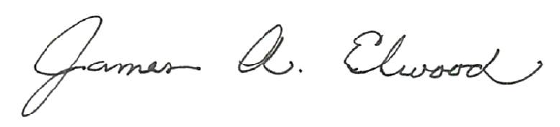
James A. Elwood
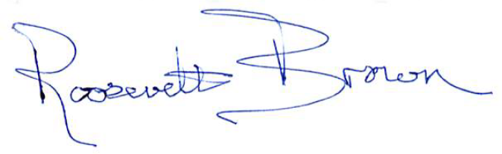
Roosevelt Brown

